Section 11B-806 Transient Lodging Guest Rooms
Diagram
UpCodes Diagrams (2)
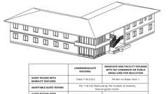
Housing at Place of Education: Grad. vs. Undergrad. (CA 11B)
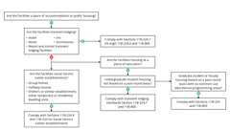
CA Housing: Education / Social Services
11B-806.1 General
Transient lodging guest rooms shall comply with Section 11B-806. Guest rooms required to provide mobility features shall comply with Section 11B-806.2. Guest rooms required to provide communication features shall comply with Section 11B-806.3.
11B-806.2 Guest Rooms With Mobility Features
Guest rooms required to provide mobility features shall comply with Section 11B-806.2.
11B-806.2.1 Living and Dining Areas
Living and dining areas shall be accessible.
11B-806.2.2 Exterior Spaces
Exterior spaces, including patios, terraces and balconies, that serve the guest room shall be accessible.
11B-806.2.3 Sleeping Areas
At least one sleeping area shall provide a 36 inch (914 mm) by 48 inch (1219 mm) minimum clear space on both sides of a bed. The clear space shall be positioned for parallel approach to the side of the bed.
Exception: Where a single clear floor space complying with Section 11B-305 positioned for parallel approach is provided between two beds, a clear floor or ground space shall not be required on both sides of a bed.
11B-806.2.3.1 Personal Lift Device Floor Space
In transient lodging facilities, clearance for the use of a personal lift device shall be provided under the bed(s) and adjacent to the clear floor space required by Section 11B-806.2.3. The clearance shall be parallel to the long side of the bed and extend under the bed to points horizontally 30 inches (762 mm), vertically 7 inches (178 mm) and not more than 12 inches (305 mm) from the head and foot end of the bed.
11B-806.2.4 Toilet and Bathing Facilities
At least one bathroom that is provided as part of a guest room shall comply with Section 11B-603. No fewer than one water closet, one lavatory and one bathtub or shower shall comply with applicable requirements of Sections 11B-603 through 11B-610. In addition, required roll-in shower compartments shall comply with Section 11B-608.2.2 or 11B-608.2.3. Toilet and bathing fixtures required to comply with Sections 11B-603 through 11B-610 shall be permitted to be located in more than one toilet or bathing area, provided that travel between fixtures does not require travel between other parts of the guest room.
Building products (9)
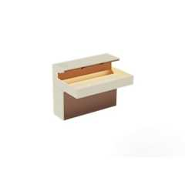
Lumashelf Integrated Sink - TSL.LUMA
The Splash Lab

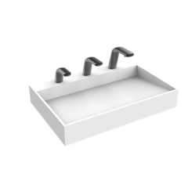
Nano Plus Sink - TSL.NANO.P
The Splash Lab


The Solo Basin / Circular - TSL.SOLO1
The Splash Lab

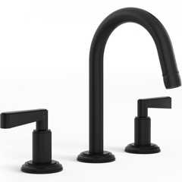
Anika Deck Mounted 3-Hole Lavatory Set
Watermark Designs

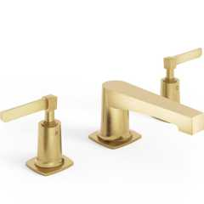
H-Line 3-Hole Deck Mounted Widespread Lavatory Set
Watermark Designs

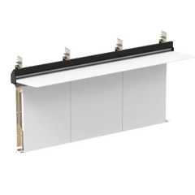
Integrated Plumbing System / Aerofoil - TSL.IPS.AERO
The Splash Lab

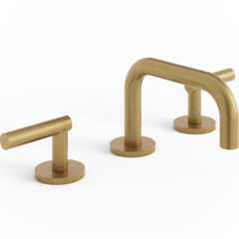
Loft Deck Mounted 3-Hole Lavatory Set
Watermark Designs

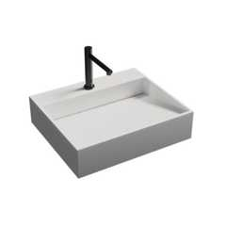
Nano Smallest ADA Sink - TSL.NANO
The Splash Lab

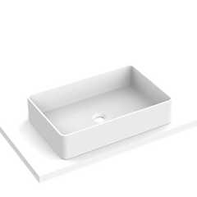
The Solo Basin / Rectangular - TSL.SOLO2
The Splash Lab

11B-806.2.4.1 Vanity Countertop Space
If vanity countertop space is provided in non-accessible guest bathrooms, toilet or bathing rooms, comparable vanity countertop space, in terms of size and proximity to the lavatory, shall also be provided in accessible guest bathrooms toilet or bathing rooms.
11B-806.2.5 Kitchens, Kitchenettes and Wet Bars
Kitchens, kitchenettes and wet bars shall comply with Section 11B-804.
Building products (2)
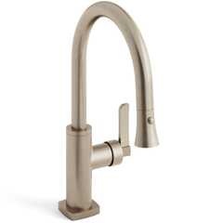
H-Line Low Gooseneck Kitchen Faucet With Pull Down Spray
Watermark Designs

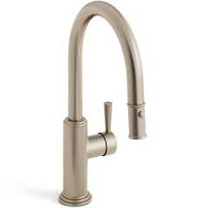
Stratford 1 Hole Gooseneck Kitchen Faucet With Pull Down Spray
Watermark Designs

11B-806.2.6 Turning Space
Turning space complying with Section 11B-304 shall be provided within the guest room.
11B-806.3 Guest Rooms With Communication Features
Guest rooms required to provide communication features shall comply with Section 11B-806.3.
11B-806.3.1 Alarms
Where emergency warning systems are provided, fire alarms shall comply with Section 11B-702 and carbon monoxide alarms shall comply with Chapter 9, Section 915.
11B-806.3.2 Notification Devices
Visible notification devices shall be provided to alert room occupants of incoming telephone calls and a door knock or bell. Notification devices shall not be connected to visible alarm signal appliances. Telephones shall have volume controls compatible with the telephone system and shall comply with Section 11B-704.3. Telephones shall be served by an electrical outlet complying with Section 11B-309 located within 48 inches (1219 mm) of the telephone to facilitate the use of a TTY.
Section 11B-807 Holding Cells and Housing Cells
11B-807.1 General
Holding cells and housing cells shall comply with Section 11B-807.
11B-807.2 Cells With Mobility Features
Cells required to provide mobility features shall comply with Section 11B-807.2.
11B-807.2.1 Turning Space
Turning space complying with Section 11B-304 shall be provided within the cell.
11B-807.2.2 Benches
Where benches are provided, at least one bench shall comply with Section 11B-903.
11B-807.2.3 Beds
Where beds are provided, clear floor space complying with Section 11B-305 shall be provided on at least one side of the bed. The clear floor space shall be positioned for parallel approach to the side of the bed.
11B-807.2.4 Toilet and Bathing Facilities
Toilet facilities or bathing facilities that are provided as part of a cell shall comply with Section 11B-603. Where provided, no fewer than one water closet, one lavatory and one bathtub or shower shall comply with the applicable requirements of Sections 11B-603 through 11B-610.
11B-807.3 Cells With Communication Features
Cells required to provide communication features shall comply with Section 11B-807.3.
11B-807.3.1 Alarms
Where audible emergency alarm systems are provided to serve the occupants of cells, visible alarms complying with Section 11B-702 shall be provided.
Exception: Visible alarms shall not be required where inmates or detainees are not allowed independent means of egress.
11B-807.3.2 Telephones
Telephones, where provided within cells, shall have volume controls complying with Section 11B-704.3.
Section 11B-808 Courtrooms
11B-808.1 General
Courtrooms shall comply with Section 11B-808.
11B-808.2 Turning Space
Where provided, areas that are raised or depressed and accessed by ramps or platform lifts with entry ramps shall provide unobstructed turning space complying with Section 11B-304.
11B-808.3 Clear Floor Space
Each jury box and witness stand shall have, within its defined area, clear floor space complying with Section 11B-305.
Exception: In alterations, wheelchair spaces are not required to be located within the defined area of raised jury boxes or witness stands and shall be permitted to be located outside these spaces where ramp or platform lift access poses a hazard by restricting or projecting into a means of egress required by the appropriate administrative authority.
11B-808.4 Judges' Benches and Courtroom Stations
Judges' benches, clerks' stations, bailiffs' stations, deputy clerks' stations, court reporters' stations and litigants' and counsel stations shall comply with Section 11B-902.
Section 11B-809 Residential Dwelling Units
Diagram
UpCodes Diagram (1)
CA Housing: Education / Social Services
11B-809.1 General
When located within public housing facilities, residential dwelling units shall comply with Section 11B-809. Residential dwelling units required to provide mobility features shall comply with Sections 11B-809.1.1 through 11B-809.1.3, and Sections 11B-809.2 through 11B-809.4. Residential dwelling units required to provide communication features shall comply with Section 11B- 809.5. Residential dwelling units with adaptable features shall comply with Section 11B-809.6.
11B-809.1.1 Door Signal Devices
In buildings with three or more residential dwelling units, the primary entry door to the dwelling unit shall be provided with a door buzzer, bell, chime or equivalent. The activating mechanism shall comply with Section 11B-309 and shall be connected to permanent wiring.
11B-809.1.2 Viewing Devices
Where primary entry doors to residential dwelling units are provided with a viewing device for a standing person, the primary entry door to a residential dwelling unit with mobility features shall also provide a lower viewing device 42 inches (1067 mm) minimum and 43 inches (1092 mm) maximum above the finish floor or ground, measured to the top of the device. The viewing device shall allow for a minimum 180 degree range of view.
11B-809.1.3 Washing Machines and Clothes Dryers
Where washing machines and clothes dryers are provided in residential dwelling units with mobility features, they shall comply with Section 11B-611. Washing machines and clothes dryers shall be front loading and shall be the same or equivalent type as provided in comparable dwelling units not required to provide mobility features.
11B-809.2 Accessible Routes
Diagram
Accessible routes complying with Division 4 shall be provided within residential dwelling units in accordance with Section 11B-809.2.
Exception: Accessible routes shall not be required to or within unfinished attics or unfinished basements.
UpCodes Diagram (1)
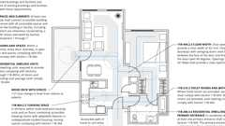
Routes: Dwelling Units (CA 11B)
11B-809.2.1 Location
At least one accessible route shall connect all spaces and elements which are a part of the residential dwelling unit. Where only one accessible route is provided, it shall not pass through bathrooms, closets or similar spaces.
11B-809.2.2 Turning Space
All rooms served by an accessible route shall provide a turning space complying with Section 11B-304.
Exception: Turning space shall not be required in exterior spaces 30 inches (762 mm) maximum in depth or width.
11B-809.3 Kitchen
Where a kitchen is provided, it shall comply with Section 11B-804.
11B-809.4 Toilet Facilities and Bathing Facilities
At least one bathroom shall comply with Section 11B-603. No fewer than one of each type of fixture provided within the bathroom shall comply with applicable requirements of Sections 11B-603 through 11B-610. Toilet and bathing fixtures required to comply with Sections 11B-603 through 11B-610 shall be located in the same bathroom or toilet and bathing area, such that travel between fixtures does not require travel between other parts of the residential dwelling unit.
Building products (5)
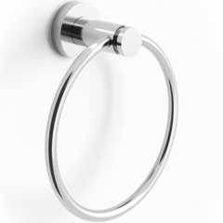
Loft 6" Diameter Wall Mounted Towel Ring
Watermark Designs

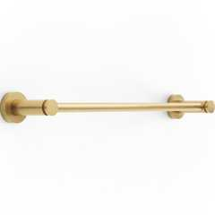
Loft Wall Mounted 18" Center-to-Center Towel Bar
Watermark Designs

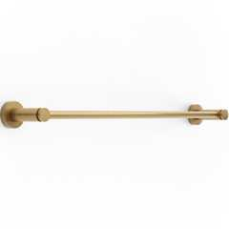
Loft Wall Mounted 24" Center-to-Center Towel Bar
Watermark Designs

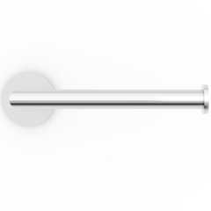
Titanium Wall Mounted Paper Holder
Watermark Designs

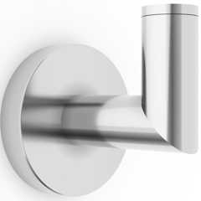
Titanium Wall Mounted Robe Hook
Watermark Designs

11B-809.4.1 Subsequent Bathrooms
In residential dwelling units with more than one bathroom, when a bathtub is installed in the first bathroom in compliance with Section 11B-809.4 and a shower compartment is provided in a subsequent bathroom, at least one shower compartment shall comply with Section 11B-608.
11B-809.5 Residential Dwelling Units With Communication Features
Residential dwelling units required to provide communication features shall comply with Section 11B-809.5.
11B-809.5.1 Building Fire Alarm System
Where a building fire alarm system is provided, the system wiring shall be extended to a point within the residential dwelling unit in the vicinity of the residential dwelling unit smoke detection system.
11B-809.5.1.1 Alarm Appliances
Where alarm appliances are provided within a residential dwelling unit as part of the building fire alarm system, they shall comply with Chapter 9, Section 907.5.2.3.3.
11B-809.5.1.2 Activation
All visible alarm appliances provided within the residential dwelling unit for building fire alarm notification shall be activated upon activation of the building fire alarm in the portion of the building containing the residential dwelling unit.
11B-809.5.2 Residential Dwelling Unit Smoke Detection System and Carbon Monoxide Detection System
Residential dwelling unit smoke detection systems shall comply with Chapter 9, Section 907.2.11. Residential dwelling unit carbon monoxide detection systems shall comply with Chapter 4.
11B-809.5.2.1 Activation
All visible alarm appliances provided within the residential dwelling unit for smoke detection notification shall be activated upon smoke detection. All visible alarm appliances provided within the residential dwelling unit for carbon monoxide detection notification shall be activated upon carbon monoxide detection.
11B-809.5.3 Interconnection
The same visible alarm appliances shall be permitted to provide notification of residential dwelling unit smoke detection, building fire alarm activation and carbon monoxide detection.
11B-809.5.4 Prohibited Use
Visible alarm appliances used to indicate residential dwelling unit smoke detection, carbon monoxide detection or building fire alarm activation shall not be used for any other purpose within the residential dwelling unit.
11B-809.5.5 Residential Dwelling Unit Primary Entrance
Communication features shall be provided at the residential dwelling unit primary entrance complying with Section 11B-809.5.5.
11B-809.5.5.1 Notification
A hard-wired electric doorbell shall be provided. A button or switch shall be provided outside the residential dwelling unit primary entrance. Activation of the button or switch shall initiate an audible tone and visible signal within the residential dwelling unit. Where visible doorbell signals are located in sleeping areas, they shall have controls to deactivate the signal.
11B-809.5.5.2 Identification
Diagram
A means for visually identifying a visitor without opening the residential dwelling unit entry door shall be provided and shall allow for a minimum 180 degree range of view.
UpCodes Diagram (1)
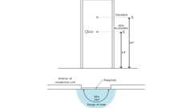
Entry Door: 180° Viewer
11B-809.5.6 Site, Building or Floor Entrance
Where a system, including a closed-circuit system, permitting voice communication between a visitor and the occupant of the residential dwelling unit is provided, the system shall comply with Section 11B-708.4.
11B-809.6 Residential Dwelling Units With Adaptable Features
Residential dwelling units with adaptable features shall comply with Sections 11B-809.7 through 11B-809.12.
11B-809.7 Accessible Routes
Diagram
An accessible route shall be provided complying with Section 11B-809.7. The accessible route shall pass through the primary entry door, through all rooms within the dwelling unit and exterior decks and balconies. The accessible route shall adjoin or overlap clear floor spaces and connect all exterior doors.
Exceptions:
- An accessible route shall not be required from the interior of the unit into a basement.
- An accessible route to a garage shall comply with Section 11B-208.3.3.
- An accessible route shall not be required to rooms or spaces not located on the primary entry level of a multistory dwelling unit.
UpCodes Diagram (1)
Routes: Dwelling Units (CA 11B)
11B-809.7.1 Width
The clear width for the accessible route shall be 36 inches (914 mm) minimum.
Exception: The clear width shall be permitted to be reduced to 32 inches (813 mm) minimum at doors.
11B-809.7.2 Changes in Level
Changes in level shall comply with Sections 11B-303.2 and 11B-303.3. Ramps complying with Section 11B-405, elevators complying with Section 11B-407 or platform lifts complying with Section 11B-410 shall be provided where changes in level exceed ¹/ ₂ inch (12.7 mm) high.
11B-809.8 Doors
Primary entry doors, required exit doors, secondary exterior doors and interior doors shall comply with Section 11B-809.8. Doors to small mechanical closets specifically dedicated to furnaces or hot water heaters shall not be required to comply with this section.
- The clear width of doors shall comply with Section 11B-404.2.3.
- Door hardware shall comply with Section 11B-404.2.7.
- Door surfaces shall comply with Section 11B-404.2.10.
- Doors in series shall comply with Section 11B-404.2.6.
11B-809.8.1 Door Thresholds
Primary entry doors, required exit doors, and interior doors intended for user passage shall have thresholds complying with Section 11B-404.2.5. Secondary exterior door thresholds, including sliding door tracks, shall be ³/₄ inch (19.1 mm) high maximum with a 1:2 maximum slope.
11B-809.8.2 Door Opening Force
Doors shall comply with Section 11B-404.2.9.
Exception: The opening force for primary entry exterior doors and secondary exterior doors shall be 8.5 pounds (38 N) maximum.
11B-809.8.3 Door Maneuvering Clearance
Minimum maneuvering clearances at doors shall comply with Section 11B-809.8.3. Maneuvering clearances shall extend the full width of the doorway and the required latch side or hinge side clearance.
- At the dwelling unit side of the primary entry doors, secondary exterior doors, and required exit doors maneuvering clearances shall be 44 inches (1118 mm) minimum in length measured perpendicular to the face of the door in the closed position. The width of the maneuvering clearance shall extend 18 inches (457 mm) beyond the strike edge at the pull side of the door.
- At interior doors maneuvering clearances shall be 42 inches (1067 mm) minimum in length on both sides of the door measured perpendicular to the face of the door in the closed position. A 39-inch (991 mm) minimum length is allowed at interior doors when a clear opening width of 34 inches (864 mm) minimum is provided. The width of the maneuvering clearance shall extend 18 inches (457 mm) beyond the strike edge at the pull side of the door.
11B-809.8.3.1 Floor or Ground Surface
Floor or ground surface within required maneuvering clearances shall not have slopes exceeding 1:48.
Exceptions: The floor or landing at primary entry doors, required exit doors and secondary exit doors where a change in elevation occurs between the interior and the exterior surface of the floor or landing, shall comply with the following:
- Exterior landings of impervious construction (e.g., concrete, brick, flagstone) serving primary entry doors and required exit doors are limited to not more than ¹/₂ inch (12.7 mm) of change in height between floor surfaces. Changes in level shall comply with Section 11B-809.7.2.
- Exterior landings of pervious construction (e.g., wood decking with spaces) shall be the same level as the interior landing, except that secondary exterior doors may have no more than ¹/₂ inch (12.7 mm) of change in height between floor surfaces. Changes in level shall comply with Section 11B-809.7.2.
- Secondary exterior doors onto decks, patios or balcony surfaces constructed of impervious materials (e.g., concrete, brick, flagstone) may have a maximum change in height from the interior landing of 4 inches (102 mm). Changes in height greater than ¹/₂ inch (12.7 mm) shall be accomplished by means of a ramp complying with Section 11B-405 or by means of a platform constructed to the level of the floor as illustrated in Figure 11B-809.8.3.1(3).
FIGURE 11B-809.8.3.1(3)—
PLATFORM AT SECONDARY EXTERIOR DOOR
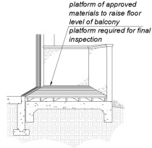
- Secondary exterior doors onto decks, patios or balcony surfaces constructed of impervious materials (e.g., concrete, brick, flagstone) may have a maximum change in height from the interior landing of 1 inch (25 mm), provided a ramp with a maximum slope of 1:8 is permanently installed as illustrated in Figure 11B-809.8.3.1(4).
FIGURE 11B-809.8.3.1(4)—
RAMP AT SECONDARY EXTERIOR DOOR
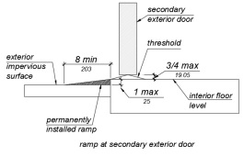
11B-809.8.4 Door Signal Devices
Every primary entrance to a residential dwelling unit with adaptable features shall be provided with a door buzzer, bell, chime or equivalent. The activating mechanism shall be mounted 48 inches (1219 mm) maximum above the floor and connected to permanent wiring.
11B-809.9 Kitchens
Diagram
Kitchens shall be on an accessible route and shall comply with this section.
UpCodes Diagram (1)
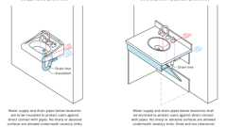
Exposed Pipes and Surfaces
Building products (2)
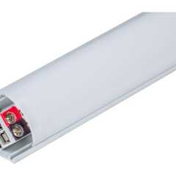
600 Lumens/Ft. Angled Linear Fixture, Tunable-White, 2700K–5000K - LT-P3
Task Lighting and Power

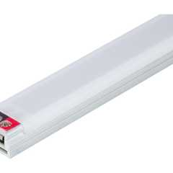
Flat Profile Linear Fixtures - Single-White - LS-P7
Task Lighting and Power

11B-809.9.1 Clear Floor Space
Diagram
Clear floor spaces 30 inches (762 mm) by 48 inches (1219 mm), with centerlines aligned with the centerline of the work surface, appliance, sink or fixture, shall be provided in the following locations:
- For a parallel approach at the range.
- For parallel or forward approach at a cooktop.
- For a parallel or forward approach to the sink and to the work surface required by Sections 11B-809.9.3 and 11B-809.9.4.
- For a parallel or forward approach to all other fixtures or appliances.
UpCodes Diagram (1)
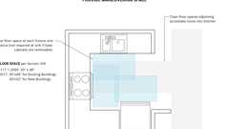
Kitchens: Clearance Overlaps (FHA)
11B-809.9.2 Clear Width
Kitchens shall have a minimum clear width measured between any cabinet, work surface or the face of any appliance (excluding handles and controls) and the opposing cabinet, work surface, appliance or wall as follows:
- U-shaped kitchens, designed with parallel approach at a sink, range, cooktop or other fixtures and appliances located at the base of the U without knee and toe clearance, shall provide a clear width of 60 inches (1524 mm) minimum.
- U-shaped kitchens, with a cooktop, sink or work surface located at the base of the U, that provides knee and toe space complying Sections 11B-809.9.3 and 11B-809.9.4 to allow for a forward approach, shall provide a clear width of 48 inches (1219 mm) minimum.
- All other kitchen designs shall provide a clear width of 48 inches (1219 mm) minimum.
FIGURE 11B-809.9.2—
CLEAR WIDTH AT KITCHENS
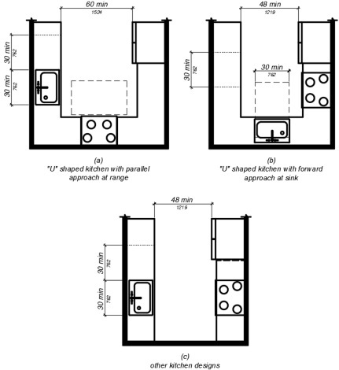
11B-809.9.3 Removable Base Cabinets
Knee and toe space complying with Section 11B-306 shall be provided at sinks and work surfaces required to comply with Section 11B-809.9.4.
Exception: Removable base cabinets shall be permitted under sinks and work surfaces provided that all of the following conditions are met:
- base cabinets can be removed without the use of specialized tools or knowledge;
- the finish floor extends under the base cabinet; and
- the walls behind and surrounding the base cabinets are finished.
11B-809.9.4 Work Surfaces
Work surfaces shall be 36 inches (914 mm) maximum above the finish floor with minimum lengths at the following locations as required by this section:
- Linear length of 30 inches (762 mm) minimum for installation of a sink.
- Linear length of 30 inches (762 mm) minimum for work surfaces.
- A sink and work surface in a single integral unit 60 inches (1524 mm) minimum in length, is permitted.
11B-809.9.5 Lower Shelving
Lower shelving and/or drawer space shall be provided at a height of 48 inches (1219 mm) maximum above the finish floor.
11B-809.9.6 Controls
Controls for faucets shall comply with Section 11B-309.1. Hand-operated metering faucets shall remain open for 10 seconds minimum.
Building products (2)
H-Line Low Gooseneck Kitchen Faucet With Pull Down Spray
Watermark Designs

Stratford 1 Hole Gooseneck Kitchen Faucet With Pull Down Spray
Watermark Designs

11B-809.9.7 Exposed Pipes and Surfaces
Diagram
Exposed water supply and drain pipes under sinks and lavatories shall comply with Section 11B-606.5.
UpCodes Diagram (1)
Primary
Exposed Pipes and Surfaces
11B-809.10 Bathrooms and Powder Rooms
11B-809.10.1 General
All bathrooms on an accessible route within residential dwelling units with adaptable features shall comply with Sections 11B-809.7, 11B-809.8, 11B-809.10.5.2, 11B-809.10.6.4, 11B-809.10.7.3 and 11B-809.12.
11B-809.10.2 Number of Complying Bathrooms and Fixtures
One bathroom and one fixture of each type within the dwelling unit shall be designed to comply with the following:
- Maneuvering space in bathrooms shall comply with Section 11B-809.10.4.
- Bathtubs shall comply with Section 11B-809.10.5.
- Showers shall comply with Section 11B-809.10.6.
- Water closets shall comply with Section 11B-809.10.7.
- Lavatories, vanities, mirrors and towel bars shall comply with Section 11B-809.10.8. When two or more lavatories are provided, at least one shall comply with Section 11B-809.10.8.
- Where both a tub and shower are provided in the bathroom, at least one shall be made accessible. Where two or more bathrooms are provided, when a bathtub is installed in the first bathroom in compliance with Section 11B-809.10.5 and a shower compartment is provided in a subsequent bathroom, at least one shower compartment shall comply with Section 11B-809.10.6.
11B-809.10.3 Powder Rooms
Powder rooms shall be designed to comply with Sections 11B-809.7, 11B-809.8, 11B-809.10.7.3 and 11B-809.12. When the powder room is the only toilet facility located on an accessible level it shall, in addition, comply with Sections 11B-809.10.4, 11B-809.10.7 and 11B-809.10.8.
11B-809.10.4 Sufficient Maneuvering Space
Where doors swing into the bathrooms or powder rooms required to comply with Section 11B-809.10, a clear maneuvering space of 30 inches (762 mm) by 48 inches (1219 mm) minimum shall be provided outside the arc of the door swing. The clear maneuvering space shall be permitted to include knee and toe clearance under bathroom fixtures. Doors shall be permitted to encroach into the clear floor space or clearance for fixtures where clear maneuvering space is provided outside the arc of the door swing. A turning space is not required within the room.
11B-809.10.5 Bathtubs
Bathtubs required by Section 11B-809.10 shall comply with this section.
11B-809.10.5.1 Clear Floor Space
A clear floor space 30 inches (762 mm) minimum by 48 inches (1219 mm) minimum shall be located with the long edge of the clear floor space parallel to the side of the bathtub or bathtub-shower combination. Controls shall be located on the wall at the foot of the bathtub. The edge of the clear floor space shall be flush with the control wall surface. The area under a lavatory, located at the control end of the tub, shall be permitted to encroach on the clear floor space provided the lavatory is 19 inches (483 mm) maximum in depth, and knee and toe clearance complying with Section 11B-306 is provided. Cabinets under lavatories and toilets shall not encroach on the clear floor space.
11B-809.10.5.2 Reinforcement for Grab Bars
Reinforcement for grabs bars shall comply with the following:
- Where bathtubs are installed without surrounding walls reinforcement shall be provided for floor-mounted grab bars.
- Where bathtubs are installed with surrounding walls, grab bar reinforcement shall be installed as follows:
  - At the control end wall and head end wall, between 30 inches (762 mm) maximum to 38 inches (965 mm) minimum above the finish floor, extending 28 inches (711 mm) minimum from the front edge of the bathtub to the back wall of the bathtub. The grab bar reinforcement shall be 8 inches (203 mm) minimum in height.
  - At the back wall, from 5 inches (127 mm) maximum above the bathtub rim to 38 inches (965 mm) minimum above the finish floor. Grab bar backing shall be installed horizontally to permit the installation of a 48-inch (1219 mm) grab bar with each end 6 inches (152 mm) maximum from the end walls of the bathtub.
FIGURE 11B-809.10.5.2—
REINFORCEMENT FOR GRAB BARS
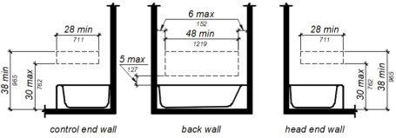
11B-809.10.5.3 Controls
Controls and operating mechanisms shall comply with Section 11B-309.4.
Exception: Shower spray units are not required in bathtubs.
Building product (1)
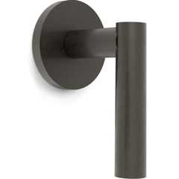
Loft Wall Mounted Trim
Watermark Designs

11B-809.10.5.4 Bathtub Enclosures
Doors and panels of bathtub enclosures shall be constructed from approved, shatter-resistant materials. Hinged doors shall open outward. Glazing used in doors and panels of bathtub enclosures shall be fully tempered, laminated safety glass or approved plastic. When glass is used, it shall be ¹/₈-inch (3.2 mm) thick minimum when fully tempered, or ¹/₄-inch (6.4 mm) thick minimum when laminated, and shall pass the test requirements of this part, Chapter 24 Glass and Glazing. Plastics used in doors and panels of bathtub enclosures shall be of a shatter-resistant type.
11B-809.10.6 Showers
Showers required by Section 11B-809.10 shall comply with this section.
11B-809.10.6.1 Size
When one or more shower stalls are provided within the same dwelling unit, at least one shower stall shall comply with one of the following:
- A transfer type shower compartment 36 inches (914 mm) wide by 36 inches (914 mm) deep, clear inside dimensions measured at center points of opposing sides, with an entrance opening 36 inches (914 mm) wide; or
- A shower stall 30 inches (762 mm) deep minimum by 60 inches (1524 mm) wide minimum with an entrance opening 60 inches (1524 mm) minimum. A water closet shall be permitted to project 12 inches (305 mm) maximum into the opening provided that 36 inches (914 mm) minimum clear space is maintained between the water closet and the shower wall as illustrated in Figure 11B-809.10.6.1; or
- A shower stall 36 inches (914 mm) deep by 60 inches (1524 mm) wide minimum with an entrance 36 inches (914 mm) minimum when a wall is installed on the opening side.
FIGURE 11B-809.10.6.1—
SHOWERS
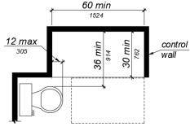
11B-809.10.6.2 Slope
The slope of the shower floor shall be ¹/₂ inch (12.7 mm) per foot maximum in any direction and shall slope to a drain. The floor surfaces shall be of Carborundum, grit-faced tile or of material providing equivalent slip resistance.
11B-809.10.6.3 Clearance
A clearance of 36 inches (914 mm) wide minimum by 48 inches (1219 mm) long minimum measured from the control wall shall be provided outside the shower as illustrated in Figure 11B-809.10.6.3.
FIGURE 11B-809.10.6.3—
TRANSFER TYPE SHOWER CLEARANCE
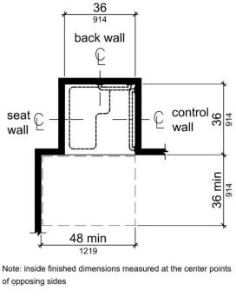
11B-809.10.6.4 Reinforcement for Grab Bars
Reinforcement for grabs bars shall comply with the following: Continuous reinforcement shall be installed in the walls of showers 30 inches (762 mm) maximum to 38 inches (965 mm) minimum above the finish floor. The grab bar reinforcement shall be 8 inches (203 mm) minimum in height. Glass-walled shower stalls shall provide reinforcement for installation of floor-mounted or ceiling-mounted grab bars.
FIGURE 11B-809.10.6.4—
REINFORCEMENT FOR GRAB BARS
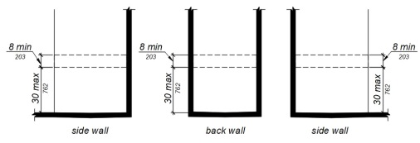
11B-809.10.6.5 Thresholds
Where provided thresholds shall be 2 inches (51 mm) maximum in height and have a beveled or sloped angle not exceeding 1 unit vertical in 2 units horizontal (26.6 degrees from the horizontal). Thresholds ¹/₂ inch (12.7 mm) or less in height shall have a beveled or sloped angle not exceeding 1 unit vertical in 1 unit horizontal (45 degrees from the horizontal).
11B-809.10.6.6 Controls
Controls and operating mechanisms shall comply with Section 11B-309.4.
Building product (1)
Loft Wall Mounted Trim
Watermark Designs

11B-809.10.6.7 Shower Enclosures
Doors and panels of shower enclosures shall comply with Section 11B-809.10.5.4.
11B-809.10.7 Water Closets
Water closets required by Section 11B-809.10 shall comply with this section.
11B-809.10.7.1 Floor Space
The floor space at water closets shall be 48 inches (1219 mm) wide minimum measured perpendicular to the side wall. A floor space 48 inches (1219 mm) wide minimum by 36 inches (914 mm) deep minimum shall be provided in front of the water closet.
Exception: The 48-inch (1219 mm) minimum clear width may be reduced to 36 inches (914 mm) minimum for lavatories, cabinets, wing walls or privacy walls located immediately adjacent to a water closet which extend 24 inches (610 mm) maximum in depth.
FIGURE 11B-809.10.7.1—
FLOOR SPACE
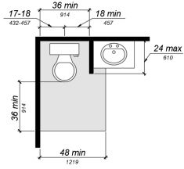
11B-809.10.7.2 Location
Water closets shall be located within bathrooms in a manner that permits a grab bar to be installed on at least one side of the fixture. The centerline of the water closet shall be 17 inches (432 mm) minimum to 18 inches (457 mm) maximum from a wall or partition that is 54 inches (1372 mm) minimum in length. In locations where water closets are adjacent to other walls, vanities, lavatories or bathtubs, the centerline of the fixture shall be 18 inches (457 mm) minimum from the obstacle.
11B-809.10.7.3 Reinforcement for Grab Bars
Reinforcement for grabs bars shall comply with the following:
- Where water closets are not placed adjacent to a side wall capable of accommodating a grab bar, the bathroom shall have provisions for installation of floor-mounted, foldaway or similar alternative grab bars.
- Where water closets are placed adjacent to a side wall, reinforcement shall be installed on both sides or one side and the back. Where reinforcement is installed at the back, it shall be installed between 30 inches (762 mm) maximum and 38 inches (965 mm) minimum above the finish floor. The grab bar reinforcement shall be 8 inches (203 mm) minimum in height. The backing shall be 40 inches (1016 mm) minimum in length.
- Where the water closet is located adjacent to lavatories, cabinets, wing walls or privacy walls, the grab bar reinforcement shall be 36 inches (914 mm) in length. Reinforcement installed at the side wall of the water closet shall be between 30 inches (762 mm) minimum to 38 inches (965 mm) maximum above the finish floor. The reinforcement shall be 10 inches (254 mm) maximum from the rear wall and shall extend 30 inches (762 mm) minimum in front of the water closet. The grab bar reinforcement shall be 8 inches (203 mm) minimum in height.
FIGURE 11B-809.10.7.3—
REINFORCEMENT FOR GRAB BARS
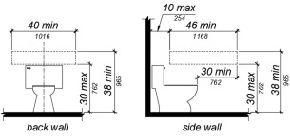
11B-809.10.7.4 Seat Height
Water closet seats shall be 15 inches (381 mm) minimum and 19 inches (483 mm) maximum measured to the top of the seat above the finish floor.
11B-809.10.7.5 Controls
Controls shall be mounted 44 inches (1118 mm) maximum above the finish floor. The force required to activate controls shall be 5 pounds (22.2 N) maximum.
11B-809.10.8 Lavatories, Vanities, Mirrors and Towel Bars
Bathrooms or powder rooms required to comply with Section 11B-809.10 shall provide lavatories complying with this section. Where mirrors or towel bars are provided, no less than one of each shall comply with this section.
11B-809.10.8.1 Location
Lavatories without base cabinets shall be installed with the centerline 18 inches (457 mm) minimum from an adjoining wall or fixture to allow for forward approach. Lavatories with base cabinets shall be installed with the centerline 24 inches (610 mm) minimum from an adjoining wall or fixture to allow for a parallel approach. The top of the lavatory rim shall be 34 inches (864 mm) maximum above the finished floor.
11B-809.10.8.2 Floor Space
A floor space 30 inches (762 mm) minimum by 48 inches (1219 mm) minimum shall be provided centered on the lavatory.
11B-809.10.8.3 Cabinets
Cabinets shall be removable without the use of specialized knowledge and/or tools. The finished floor shall extend to the wall under the lavatory.
11B-809.10.8.4 Knee and Toe Clearance
Knee and toe clearance shall be provided and comply with Section 11B-306.
11B-809.10.8.5 Plumbing Protection
Plumbing protection shall comply with Section 11B-809.9.7.
11B-809.10.8.6 Controls
Faucet controls and operating mechanisms shall comply with Section 11B-309.4.
Building products (3)
Anika Deck Mounted 3-Hole Lavatory Set
Watermark Designs

H-Line 3-Hole Deck Mounted Widespread Lavatory Set
Watermark Designs

Loft Deck Mounted 3-Hole Lavatory Set
Watermark Designs

11B-809.10.8.7 Mirrors and Towel Bars
Where mirrors are provided the bottom edge of the reflective surface shall be 40 inches (1016 mm) maximum above the finish floor. Where towel bars are provided, they shall be installed 40 inches (1016 mm) maximum above the finish floor to the top of the bar.
Building products (3)
Loft 6" Diameter Wall Mounted Towel Ring
Watermark Designs

Loft Wall Mounted 18" Center-to-Center Towel Bar
Watermark Designs

Loft Wall Mounted 24" Center-to-Center Towel Bar
Watermark Designs

11B-809.11 Washing Machines and Clothes Dryers
Where washing machines and clothes dryers are provided in residential dwelling units with adaptable features, one of each type shall be provided.
11B-809.12 Electrical Receptacles, Controls and Switches
Electrical receptacles on branch circuits of 30 amperes or less, communication system receptacles, controls and switches shall be located as follows:
- Where there is no obstruction, 48 inches (1219 mm) maximum measured from the top of the receptacle box and 15 inches (381 mm) minimum measured from the bottom of the receptacle box to the finish floor.
- Where the reach is over an obstruction, electrical receptacles, controls and switches shall comply with Sections 11B-308.3 and 11B-309.2.
- When the reach is over a kitchen work surface and base cabinet, the work surface shall be 36 inches (914 mm) maximum above the finish floor and 25¹/₂ inches (650 mm) maximum in depth. The base cabinet shall be 24 inches (610 mm) maximum in depth.
- Where receptacles are provided in a kitchen at a corner work surface, one receptacle shall be located 36 inches (915 mm) from either wall at the inside corner.
Exceptions:
- Electrical receptacles installed as part of permanently installed baseboard heaters.
- Electrical receptacles in floors adjacent to sliding panels or walls.
- Baseboard electrical receptacles in relocatable partitions, window walls or other electrical convenience floor outlets.
- Appliances (e.g., stoves, dishwashers, range hoods, microwave ovens and similar appliances) which have controls located on the appliance.
- Electrical receptacles dedicated to specific appliances.
- Circuit breakers.
FIGURE 11B-809.12—
ELECTRICAL RECEPTACLES AT CORNER WORKSURFACES
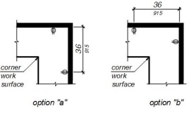
Section 11B-810 Transportation Facilities
11B-810.1 General
Transportation facilities shall comply with Section 11B-810.
11B-810.1.1 Vehicle Boarding
Stations shall not be designed or constructed so as to require persons with disabilities to board or alight from a vehicle at a location other than one used by the general public.
11B-810.1.2 Baggage Systems
Baggage check-in and retrieval systems shall be on an accessible route complying with Section 11B-402 and shall have space immediately adjacent complying with Section 11B-302.
11B-810.2 Bus Boarding and Alighting Areas
Bus boarding and alighting areas shall comply with Section 11B-810.2.
11B-810.2.1 Surface
Bus stop boarding and alighting areas shall have a firm, stable surface.
11B-810.2.2 Dimensions
Bus stop boarding and alighting areas shall provide a clear length of 96 inches (2438 mm) minimum, measured perpendicular to the curb or vehicle roadway edge, and a clear width of 60 inches (1524 mm) minimum, measured parallel to the vehicle roadway.
FIGURE 11B-810.2.2—
DIMENSIONS OF BUS BOARDING AND ALIGHTING AREAS
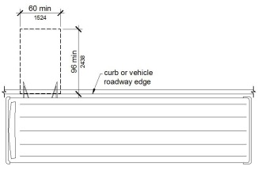
11B-810.2.3 Connection
Bus stop boarding and alighting areas shall be connected to streets, sidewalks or pedestrian paths by an accessible route complying with Section 11B-402. Newly constructed bus stop boarding and alighting areas shall provide a detectable transition between the boarding/alighting area and the roadway; the detectable transition shall consist of a curb with the face sloped at 35 degrees maximum from vertical or detectable warnings complying with Sections 11B-705.1.1 and 11B-705.1.2.4.
11B-810.2.4 Slope
Parallel to the roadway, the slope of the bus stop boarding and alighting area shall be the same as the roadway, to the maximum extent practicable. Perpendicular to the roadway, the slope of the bus stop boarding and alighting area shall not be steeper than 1:48.
11B-810.3 Bus Shelters
Bus shelters shall provide a minimum clear floor or ground space complying with Section 11B-305 entirely within the shelter. Bus shelters shall be connected by an accessible route complying with Section 11B-402 to a boarding and alighting area complying with Section 11B-810.2.
FIGURE 11B-810.3—
BUS SHELTERS
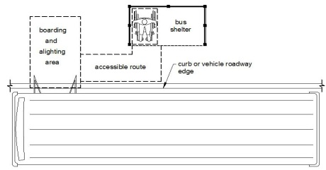
11B-810.4 Bus Signs
Bus route identification signs shall comply with Sections 11B-703.5.1 through 11B-703.5.4 and Sections 11B-703.5.7 and 11B-703.5.8. In addition, to the maximum extent practicable, bus route identification signs shall comply with Section 11B-703.5.5.
Exception: Bus schedules, timetables and maps that are posted at the bus stop or bus bay shall not be required to comply.
11B-810.5 Rail Platforms
Rail platforms shall comply with Section 11B-810.5.
11B-810.5.1 Slope
Rail platforms shall not exceed a slope of 1:48 in all directions.
Exception: Where platforms serve vehicles operating on existing track or track laid in existing roadway, the slope of the platform parallel to the track shall be permitted to be equal to the slope (grade) of the roadway or existing track.
11B-810.5.2 Detectable Warnings
Platform boarding edges not protected by platform screens or guards shall have detectable warnings complying with Section 11B-705 along the full length of the public use area of the platform.
11B-810.5.3 Platform and Vehicle Floor Coordination
Station platforms shall be positioned to coordinate with vehicles in accordance with the applicable requirements of 36 CFR Part 1192. Low-level platforms shall be 8 inches (203 mm) minimum above top of rail.
Exception: Where vehicles are boarded from sidewalks or street-level, low-level platforms shall be permitted to be less than 8 inches (203 mm).
11B-810.6 Rail Station Signs
Rail station signs shall comply with Section 11B-810.6.
Exception: Signs shall not be required to comply with Sections 11B-810.6.1 and 11B-810.6.2 where audible signs are remotely transmitted to hand-held receivers or are user- or proximity-actuated.
11B-810.6.1 Entrances
Where signs identify a station or its entrance, at least one sign at each entrance shall comply with Section 11B-703.2 and shall be placed in uniform locations to the maximum extent practicable. Where signs identify a station that has no defined entrance, at least one sign shall comply with Section 11B-703.2 and shall be placed in a central location.
11B-810.6.2 Routes and Destinations
Lists of stations, routes and destinations served by the station which are located on boarding areas, platforms or mezzanines shall comply with Section 11B-703.5. At least one tactile sign identifying the specific station and complying with Section 11B-703.2 shall be provided on each platform or boarding area. Signs covered by this requirement shall, to the maximum extent practicable, be placed in uniform locations within the system.
Exception: Where sign space is limited, characters shall not be required to exceed 3 inches (76 mm).
11B-810.6.3 Station Names
Stations covered by this section shall have identification signs complying with Section 11B-703.5. Signs shall be clearly visible and within the sight lines of standing and sitting passengers from within the vehicle on both sides when not obstructed by another vehicle.
11B-810.7 Public Address Systems
Where public address systems convey audible information to the public, the same or equivalent information shall be provided in a visual format.
11B-810.8 Clocks
Where clocks are provided for use by the public, the clock face shall be uncluttered so that its elements are clearly visible. Hands, numerals and digits shall contrast with the background either light-on-dark or dark-on-light. Where clocks are installed overhead, numerals and digits shall comply with Section 11B-703.5.
11B-810.9 Escalators
Where provided, escalators shall comply with Sections 6.1.3.5.6 and 6.1.3.6.5 of ASME A17.1 and shall have a clear width of 32 inches (813 mm) minimum.
Exception: Existing escalators in key stations shall not be required to comply with Section 11B-810.9.
11B-810.10 Track Crossings
Where a circulation path serving boarding platforms crosses tracks, it shall comply with Section 11B-402.
Exception: Openings for wheel flanges shall be permitted to be 2¹/₂ inches (64 mm) maximum.
FIGURE 11B-810.10(EXCEPTION)—TRACK CROSSINGS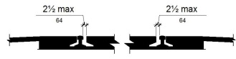
Section 11B-811 Storage
Building products (5)
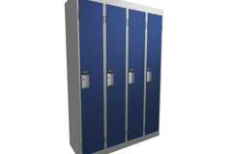
Corridor (Emperor) Lockers
Hadrian Solutions ULC

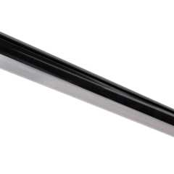
Lighted Closet Rod - Tunable-white, Aluminum Profile, Frosted Lens, White - LCR-T
Task Lighting and Power

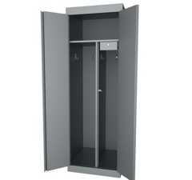
Specialty Lockers
Hadrian Solutions ULC

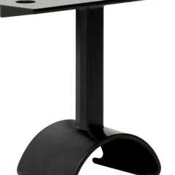
Top-Mounted Support, Lighted Closet Rod - L-LCR-HS
Task Lighting and Power

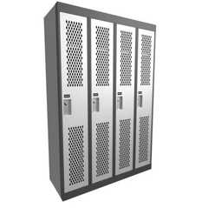
​​Athletic (Gladiator) Lockers
Hadrian Solutions ULC

11B-811.1 General
Storage shall comply with Section 11B-811.
11B-811.2 Clear Floor or Ground Space
A clear floor or ground space complying with Section 11B-305 shall be provided.
11B-811.3 Height
Storage elements shall comply with at least one of the reach ranges specified in Section 11B-308.
11B-811.4 Operable Parts
Operable parts shall comply with Section 11B-309.
Section 11B-812 Electric Vehicle Charging Stations
Diagram
UpCodes Diagram (1)
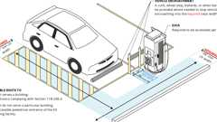
EV Charging Stations Relationship to Accessible Routes (CA 11B)
11B-812.1 General
Electric vehicle charging stations (EVCS) shall comply with Section 11B-812 as required by Section 11B-228.3. Where vehicle spaces and access aisles are marked with lines, measurements shall be made from the centerline of the markings.
Exception: Where vehicle spaces or access aisles are not adjacent to another vehicle space, access aisle or parking space, measurements shall be permitted to include the full width of the line defining the vehicle space or access aisle.
11B-812.2 Operable Parts
Operable parts shall comply with Section 11B-309.
11B-812.3 Floor or Ground Surfaces
Vehicle spaces and access aisles serving them shall comply with Section 11B-302. Access aisles shall be at the same level as the vehicle space they serve. Changes in level, slopes exceeding 1:48, and detectable warnings shall not be permitted.
11B-812.4 Vertical Clearance
Vehicle spaces, access aisles serving them, and vehicular routes serving them shall provide a vertical clearance of 98 inches (2489 mm) minimum. Where provided, overhead cable management systems shall not obstruct required vertical clearance.
11B-812.5 Accessible Routes
11B-812.5.1 Accessible Route to Building or Facility
EVCS complying with Section 11B-812 that serve a particular building or facility shall be located on an accessible route to an entrance complying with Section 11B-206.4. Where EVCS do not serve a particular building or facility, EVCS complying with Section 11B-812 shall be located on an accessible route to an accessible pedestrian entrance of the EV charging facility.
Exception: EVCS complying with Section 11B-812 shall be permitted to be located in different EV charging facilities if substantially equivalent or greater accessibility is provided in terms of distance from an accessible entrance or entrances, charging fee, and user convenience.
11B-812.5.2 Accessible Route to EV Charger
An accessible route complying with Section 11B-402 shall connect the vehicle space and the EV charger which serves it.
11B-812.5.3 Relationship to Accessible Routes
Diagram
Vehicle spaces and access aisles shall be designed so that when the vehicle space is occupied the required clear width of adjacent accessible routes is not obstructed. A curb, wheel stop, bollards or other barrier shall be provided if required to prevent encroachment of vehicles over the required clear width of adjacent accessible routes.
UpCodes Diagram (1)
Primary
EV Charging Stations Relationship to Accessible Routes (CA 11B)
11B-812.5.4 Arrangement
Vehicle spaces and access aisles shall be designed so that persons using them are not required to travel behind vehicle spaces or parking spaces other than the vehicle space in which their vehicle has been left to charge.
Exceptions:
- Ambulatory EVCS shall not be required to comply with Section 11B-812.5.4.
- Vehicle spaces installed in existing facilities shall comply with Section 11B-812.5.4 to the maximum extent feasible.
11B-812.5.5 Obstructions
EVCS shall be designed so accessible routes are not obstructed by cables or other elements.
11B-812.6 Vehicle Spaces
Vehicle spaces serving van accessible, standard accessible, ambulatory and drive-up EVCS shall be 216 inches (5486 mm) long minimum and shall com ply with Sections 11B-812.6.1 through 11B-812.6.4 as applicable. All vehicle spaces shall be marked to define their width.
Exceptions:
- Where the long dimension of vehicle spaces is parallel to the traffic flow in the adjacent vehicular way, the length of vehicle spaces shall be 240 inches (6096 mm) minimum.
- Vehicle spaces at drive-up EVCS shall be 240 inches (6096 mm) long minimum and shall not be required to be marked to define their width.
11B-812.6.1 Van Accessible
Vehicle spaces serving van accessible EVCS shall be 144 inches (3658 mm) wide minimum and shall have an adjacent access aisle complying with Section 11B-812.7.
11B-812.6.2 Standard Accessible
Vehicle spaces serving standard accessible EVCS shall be 108 inches (2743 mm) wide minimum and shall have an adjacent access aisle complying with Section 11B-812.7.
11B-812.6.3 Ambulatory
Vehicle spaces serving ambulatory EVCS shall be 120 inches (3048 mm) wide minimum and shall not be required to have an adjacent access aisle.
11B-812.6.4 Drive-Up
Vehicle spaces serving drive-up EVCS shall be 204 inches (5182 mm) wide minimum and shall not be required to have an adjacent access aisle.
11B-812.7 Access Aisle
Access aisles shall adjoin an accessible route. Two vehicle spaces or one parking space and one electric vehicle charging space shall be permitted to share a common access aisle. Access aisles shall be 60 inches (1524 mm) wide minimum and shall extend the full required length of the vehicle spaces they serve.
11B-812.7.1 Location
Access aisles at vehicle spaces shall not overlap the vehicular way and may be placed on either side of the vehicle space they serve except for van accessible spaces which shall have access aisles located on the passenger side of the vehicle spaces.
Exception: Where four or fewer total EVCS are provided within a facility, the access aisle for non-angled van accessible spaces may be located on either the driver or passenger side of the vehicle space.
11B-812.7.2 Marking
Access aisles at vehicle spaces shall be marked with a painted borderline around their perimeter. The area within the borderlines shall be marked with hatched lines a maximum of 36 inches (914 mm) on center. The color of the borderlines, hatched lines and letters shall contrast with that of the surface of the access aisle. The blue color required for identification of access aisles for accessible parking shall not be used. Access aisle markings may extend beyond the minimum required length.
Exception: Where one parking space and one electric vehicle charging space share an access aisle, access aisle marking shall comply with Section 11B-502.3.3 and shall not be required to comply with Section 11B- 812.7.2.
11B-812.7.3 Lettering
The words "NO PARKING" shall be painted on the surface within each access aisle in letters a minimum of 12 inches (305 mm) in height and located to be visible from the adjacent vehicular way.
11B-812.8 Identification Signs
EVCS identification signs shall be provided in compliance with Section 11B-812.8.
11B-812.8.1 Four or Fewer
Where four or fewer total EVCS are provided, identification with an International Symbol of Accessibility (ISA) and signs identifying van accessible spaces shall not be required.
11B-812.8.2 Five to Twenty-Five
Where five to twenty-five total EVCS are provided, one van accessible EVCS shall be identified by an ISA complying with Section 11B-703.7.2.1. The required standard accessible EVCS shall not be required to be identified with an ISA.
11B-812.8.3 Twenty-Six or More
Where twenty-six or more total EVCS are provided, all required van accessible and all required standard accessible EVCS shall be identified by an ISA complying with Section 11B-703.7.2.1.
11B-812.8.4 Ambulatory
Ambulatory EVCS shall not be required to be identified by an ISA.
11B-812.8.5 Drive-Up
Drive-up EVCS shall not be required to be identified by an ISA.
11B-812.8.6 Finish and Size
Identification signs shall be reflectorized with a minimum area of 70 square inches (45 161 mm²).
11B-812.8.7 Location
Required identification signs shall be visible from the EVCS it serves. Signs shall be permanently posted either immediately adjacent to the vehicle space or within the projected vehicle space width at the head end of the vehicle space. Signs identifying van accessible vehicle spaces shall contain the designation "van accessible." Signs shall be 60 inches (1525 mm) minimum above the finish floor or ground surface measured to the bottom of the sign. Signs located within a circulation path shall be 80 inches (2032 mm) minimum above the finish floor or ground surface measured to the bottom of the sign. Signs may also be permanently posted on a wall at the interior end of the vehicle space.
11B-812.9 Surface Marking
EVCS vehicle spaces shall provide surface marking stating "EV CHARGING ONLY" in letters 12 inches (305 mm) high minimum. The centerline of the text shall be a maximum of 6 inches (152 mm) from the centerline of the vehicle space and its lower corner at, or lower side aligned with, the end of the vehicle space length.
FIGURE 11B-812.9—
SURFACE MARKING
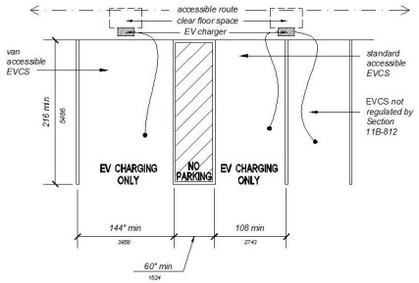
11B-812.10 Electric Vehicle Chargers
11B-812.10.1 General
EV chargers shall comply with Section 11B-812.10.
11B-812.10.2 Operable Parts
Operable parts and charging cord storage shall comply with Section 11B-309.
11B-812.10.3 Point-of-Sale Devices
Where provided, point-of-sale devices shall comply with Sections 11B-707.2, 11B-707.3, 11B-707.7.2 and 11B-707.9.
11B-812.10.4 Location
EV chargers shall be adjacent to, and within the projected width of, the vehicle space being served.
Exceptions:
- EV chargers serving more than one EVCS shall be adjacent to, and within the combined projected width of, the vehicle spaces being served.
- For alterations at existing facilities where an accessible route or general circulation path is not provided adjacent to the head end of the vehicle space or access aisle, the EV charger may be located within the projected width of the access aisle 36 inches (914 mm) maximum from the head end of the space.
- Where the long dimension of a vehicle space is parallel to the vehicular way, the EV charger shall be adjacent to, and 48 inches (1219 mm) maximum from the head end or foot end of the vehicle space or access aisle being served.
Section 11B-813 Adult Changing Facilities
11B-813 Adult Changing Facilities
Adult changing facilities shall comply with Section 11B-813.
11B-813.1 Location
Adult changing facilities shall be provided within a unisex (single-user or family) toilet room or other similar privateroom.
11B-813.2 Features
Adult changing facilities shall provide features in compliance with Section 11B-813.2.
11B-813.2.1 Adult Changing Table
Adult changing tables shall be fixed to the floor or a wall and shall comply with Section 11B-813.2.1.
11B-813.2.1.1 Size
Adult changing tables shall have a changing surface of 70 inches (1778 mm) minimum length and 30 inches (762 mm) minimum width.
11B-813.2.1.2 Clearance
A 36 inches (914 mm) minimum width side clearance shall be provided along the entire length of one side of adult changing tables. At both ends of adult changing tables, clearance shall be provided measuring 36 inches (914 mm) minimum wide and a minimum length as long as the table width plus the width of the side clearance. End and side clearances shall be measured from the outermost extent of the table. Floor or ground surfaces of clearances shall comply with Section 11B-302. Changes in level are not permitted.
FIGURE 11B-813.2.1.2—
CLEARANCE AROUND ADULT CHANGING TABLE
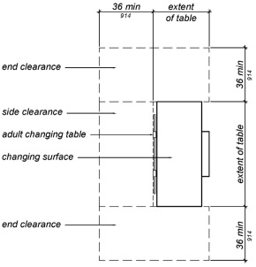
11B-813.2.1.3 Height and Operation
Adult changing table height shall be adjustable from 17 inches (432 mm) above the floor or ground to 38 inches (965 mm) above the floor or ground, as measured to the top of the changing surface. Height adjustability shall be powered. Operable parts shall comply with Section 11B-309.
11B-813.2.1.4 Capacity
Adult changing tables shall provide a minimum weight capacity of 300 pounds (136 kg).
11B-813.2.1.5 Obstructions
When deployed, changing tables shall not obstruct the required width of an accessible route except as allowed by Section 11B-307.2.
11B-813.2.2 Water Closet
No fewer than one water closet in compliance with Section 11B-604.
11B-813.2.3 Lavatory
One lavatory in compliance with Section 11B-606.
11B-813.2.4 Waste Receptacle
No fewer than one waste receptacle in compliance with Section 11B-603.5.
11B-813.2.5 Coat Hook
No fewer than one coat hook shall be provided in close proximity to the changing table and within one of the reach ranges specified in Section 11B-308.
11B-813.2.6 Shelf
No fewer than one shelf shall be provided in close proximity to the changing table at 40 inches (1016 mm) minimum and 48 inches (1219 mm) maximum above the finish floor.
11B-813.2.7 Accessories
Where provided, no fewer than one of each accessory shall comply with Section 11B-603.5.
11B-813.2.8 Turning Space
Turning space complying with Section 11B-304 shall be provided within adult changing facilities.
11B-813.2.9 Overlap
Required clear floor spaces, clearance at fixtures and turning space shall be permitted to overlap.
11B-813.2.10 Door Swing
A door, in any position, shall be permitted to encroach into the turning space by 12 inches (305 mm) maximum. Where a clear floor space complying with Section 11B-305.3 is provided within the room beyond the arc of the door swing, doors shall be permitted to swing into the clear floor space, clearance required for any fixture and clearance required for adult changing tables.
11B-813.2.11 Privacy Latch
Each door to adult changing facilities shall have a privacy latch.
11B-813.2.12 Signs
A room identification sign complying with Section 11B-216 shall be provided at entrances to adult changing facilities. The text of the room identification sign shall be "ADULT CHANGING ROOM".
An informational sign complying with Section 11B-216 shall be provided within adult changing facilities and in close proximity to the changing table. The informational sign shall indicate the maximum weight capacity of the adult changing table, as determined by the table manufacturer.
Where the commercial place of public amusement has a central directory, the central directory shall indicate the location of adult changing facilities. Where other directories indicate the location of toilet facilities, the other directories shall also indicate the location of adult changing facilities.
Division 9 Built-In Elements
Section 11B-901 General
11B-901.1 Scope
The provisions of Division 9 shall apply where required by Division 2 or where referenced by a requirement in this chapter .
Section 11B-902 Dining Surfaces and Work Surfaces
11B-902.1 General
Diagram
Dining surfaces and work surfaces shall comply with Sections 11B-902.2 and 11B-902.3.
Exception: Dining surfaces and work surfaces for children's use shall be permitted to comply with Section 11B-902.4.
UpCodes Diagrams (2)
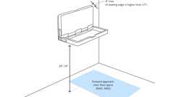
Baby Changing Tables
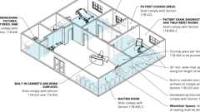
Professional Offices of Health Care Providers
Building products (4)
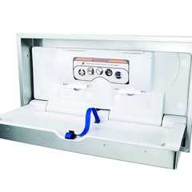
DryBaby - ABC-300HSR
World Dryer

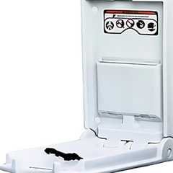
DryBaby® - ABC-300V
World Dryer

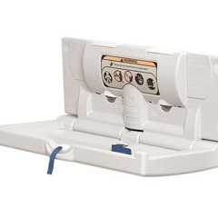
DryBaby® - ABC-300H
World Dryer

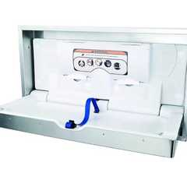
DryBaby® - ABC-300HS
World Dryer

11B-902.2 Clear Floor or Ground Space
A clear floor space complying with Section 11B-305 positioned for a forward approach shall be provided. Knee and toe clearance complying with Section 11B-306 shall be provided.
11B-902.2.1 Overlap
The clear floor space at dining surfaces shall not overlap the accessible route.
11B-902.3 Height
The tops of dining surfaces and work surfaces shall be 28 inches (711 mm) minimum and 34 inches (864 mm) maximum above the finish floor or ground.
11B-902.4 Dining Surfaces and Work Surfaces for Children's Use
Accessible dining surfaces and work surfaces for children's use shall comply with Section 11B-902.4.
Exception: Dining surfaces and work surfaces that are used primarily by children 5 years and younger shall not be required to comply with Section 11B-902.4 where a clear floor or ground space complying with Section 11B-305 positioned for a parallel approach is provided.
11B-902.4.1 Clear Floor or Ground Space
A clear floor space complying with Section 11B-305 positioned for forward approach shall be provided. Knee and toe clearance complying with Section 11B-306 shall be provided, except that knee clearance 24 inches (610 mm) minimum above the finish floor or ground shall be permitted.
11B-902.4.2 Height
The tops of tables and counters shall be 26 inches (660 mm) minimum and 30 inches (762 mm) maximum above the finish floor or ground.
Section 11B-903 Benches
Diagram
UpCodes Diagram (1)
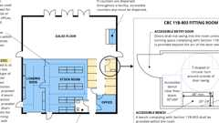
Retail (CA 11B)
11B-903.1 General
Diagram
Benches shall comply with Section 11B-903.
UpCodes Diagram (1)
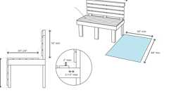Primary
Benches (CA 11B)
11B-903.2 Clear Floor or Ground Space
Clear floor or ground space complying with Section 11B-305 shall be provided and shall be positioned at the end of the bench seat and parallel to the short axis of the bench.
11B-903.3 Size
Benches shall have seats that are 48 inches (1219 mm) long minimum and 20 inches (508 mm) deep minimum and 24 inches (610 mm) deep maximum.
11B-903.4 Back Support
The bench shall provide for back support or shall be affixed to a wall along its long dimension. Back support shall be 48 inches (1219 mm) long minimum and shall extend from a point 2 inches (51 mm) maximum above the seat surface to a point 18 inches (457 mm) minimum above the seat surface. Back support shall be 2¹/₂ inches (64 mm) maximum from the rear edge of the seat measured horizontally.
FIGURE 11B-903.4—
BENCH BACK SUPPORT
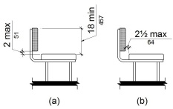
11B-903.5 Height
The top of the bench seat surface shall be 17 inches (432 mm) minimum and 19 inches (483 mm) maximum above the finish floor or ground.
11B-903.6 Structural Strength
Benches shall be affixed to the wall or floor. Allowable stresses shall not be exceeded for materials used when a vertical or horizontal force of 250 pounds (1112 N) is applied at any point on the seat, fastener, mounting device or supporting structure.
11B-903.7 Wet Locations
Where installed in wet locations, the surface of the seat shall be slip resistant and shall not accumulate water.
Section 11B-904 Check-Out Aisles and Sales and Service Counters
11B-904.1 General
Check-out aisles and sales and service counters shall comply with the applicable requirements of Section 11B-904.
11B-904.2 Approach
All portions of counters required to comply with Section 11B-904 shall be located adjacent to a walking surface complying with Section 11B-403.
11B-904.3 Check-Out Aisles
Diagram
Check-out aisles shall comply with Section 11B-904.3.
UpCodes Diagrams (2)
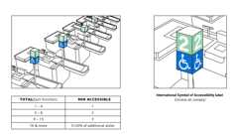
Check-Out Aisles
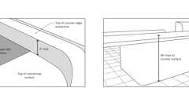
Check-Out Aisles: Counter Surface (ADA)
11B-904.3.1 Aisle
Aisles shall comply with Section 11B-403.
11B-904.3.2 Counter
The counter surface height shall be 38 inches (965 mm) maximum above the finish floor or ground. The top of the counter edge protection shall be 2 inches (51 mm) maximum above the top of the counter surface on the aisle side of the check-out counter.
FIGURE 11B-904.3.2—
CHECK-OUT AISLE COUNTERS
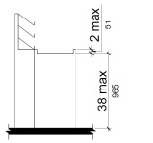
11B-904.3.3 Check Writing Surfaces
Where provided, check writing surfaces shall comply with Section 11B-902.3.
11B-904.3.4 Identification Sign
When not all check-out aisles are accessible, accessible check-out aisles shall be identified by a sign clearly visible to a person in a wheelchair displaying the International Symbol of Accessibility complying with Section 11B-703.7.2.1. The sign shall be a minimum of 4 inches by 4 inches (102 mm by 102 mm).
11B-904.4 Sales and Service Counters
Diagram
Sales counters and service counters shall comply with Section 11B-904.4.1 or 11B-904.4.2. The accessible portion of the countertop shall extend the same depth as the sales or service countertop.
Exception: In alterations, when the provision of a counter complying with Section 11B-904.4 would result in a reduction of the number of existing counters at work stations or a reduction of the number of existing mail boxes, the counter shall be permitted to have a portion which is 24 inches (610 mm) long minimum complying with Section 11B-904.4.1 provided that the required clear floor or ground space is centered on the accessible length of the counter.
FIGURE 11B-904.4 (EXCEPTION)—
ALTERATION OF SALES AND SERVICE COUNTERS
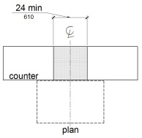
UpCodes Diagrams (4)
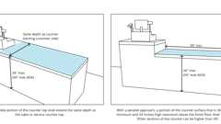Primary
Sales and Service Counters - Height & Depth (CA)
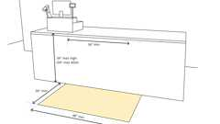
Sales and Service Counters - Parallel Approach (CA)
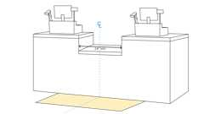
Sales and Service Counters - Exception
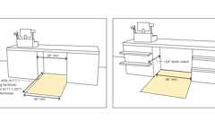
Sales and Service Counters - Forward Approach
11B-904.4.1 Parallel Approach
Diagram
A portion of the counter surface that is 36 inches (914 mm) long minimum and 34 inches (864 mm) high maximum above the finish floor shall be provided. A clear floor or ground space complying with Section 11B-305 shall be positioned for a parallel approach adjacent to the 36 inch (914 mm) minimum length of counter.
Exception: Where the provided counter surface is less than 36 inches (914 mm) long, the entire counter surface shall be 34 inches (864 mm) high maximum above the finish floor.
UpCodes Diagram (1)
Primary
Sales and Service Counters - Parallel Approach (CA)
11B-904.4.2 Forward Approach
A portion of the counter surface that is 36 inches (914 mm) long minimum and 34 inches (864 mm) high maximum shall be provided. Knee and toe space complying with Section 11B-306 shall be provided under the counter. A clear floor or ground space complying with Section 11B-305 shall be positioned for a forward approach to the counter.
11B-904.5 Food Service Lines
Diagram
Counters in food service lines shall comply with Section 11B-904.5.
UpCodes Diagrams (2)
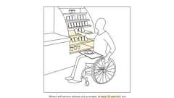
Food Service: Self-Service Shelves
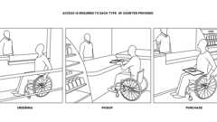
Food Service Counters (ADA)
11B-904.5.1 Self-Service Shelves and Dispensing Devices
Diagram
Self-service shelves and dispensing devices for tableware, dishware, condiments, food and beverages shall comply with Section 11B-308.
UpCodes Diagram (1)
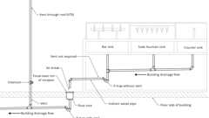
Vents Not Required: Bars, Soda Fountains, and Counter
11B-904.5.2 Tray Slides
The tops of tray slides shall be 28 inches (711 mm) minimum and 34 inches (864 mm) maximum above the finish floor or ground.
11B-904.6 Security Glazing
Where counters or teller windows have security glazing to separate personnel from the public, a method to facilitate voice communication shall be provided. Telephone handset devices, if provided, shall comply with Section 11B-704.3.
Division 10 Recreation Facilities
Section 11B-1001 General
11B-1001.1 Scope
The provisions of Division 10 shall apply where required by Division 2 or where referenced by a requirement in this chapter .
Section 11B-1002 Amusement Rides
11B-1002.1 General
Amusement rides shall comply with Section 11B-1002.
11B-1002.2 Accessible Routes
Accessible routes serving amusement rides shall comply with Division 4.
Exceptions:
- In load or unload areas and on amusement rides, where compliance with Section 11B-405.2 is not structurally or operationally feasible, ramp slope shall be permitted to be 1:8 maximum.
- In load or unload areas and on amusement rides, handrails provided along walking surfaces complying with Section 11B-403 and required on ramps complying with Section 11B-405 shall not be required to comply with Section 11B-505 where compliance is not structurally or operationally feasible.
11B-1002.3 Load and Unload Areas
A turning space complying with Sections 11B-304.2 and 11B-304.3 shall be provided in load and unload areas.
11B-1002.4 Wheelchair Spaces in Amusement Rides
Wheelchair spaces in amusement rides shall comply with Section 11B-1002.4.
11B-1002.4.1 Floor or Ground Surface
The floor or ground surface of wheelchair spaces shall be stable and firm.
11B-1002.4.2 Slope
The floor or ground surface of wheelchair spaces shall have a slope not steeper than 1:48 when in the load and unload position.
11B-1002.4.3 Gaps
Floors of amusement rides with wheelchair spaces and floors of load and unload areas shall be coordinated so that, when amusement rides are at rest in the load and unload position, the vertical difference between the floors shall be within plus or minus ⁵/₈ inches (15.9 mm) and the horizontal gap shall be 3 inches (76 mm) maximum under normal passenger load conditions.
Exception: Where compliance is not operationally or structurally feasible, ramps, bridge plates or similar devices complying with the applicable requirements of 36 CFR 1192.83(c) shall be provided.
11B-1002.4.4 Clearances
Clearances for wheelchair spaces shall comply with Section 11B-1002.4.4.
Exceptions:
- Where provided, securement devices shall be permitted to overlap required clearances.
- Wheelchair spaces shall be permitted to be mechanically or manually repositioned.
- Wheelchair spaces shall not be required to comply with Section 11B-307.4.
11B-1002.4.4.1 Width and Length
Wheelchair spaces shall provide a clear width of 30 inches (762 mm) minimum and a clear length of 48 inches (1219 mm) minimum measured to 9 inches (229 mm) minimum above the floor surface.
11B-1002.4.4.2 Side Entry
Where wheelchair spaces are entered only from the side, amusement rides shall be designed to permit sufficient maneuvering clearance for individuals using a wheelchair or mobility aid to enter and exit the ride.
11B-1002.4.4.3 Permitted Protrusions in Wheelchair Spaces
Objects are permitted to protrude a distance of 6 inches (152 mm) maximum along the front of the wheelchair space, where located 9 inches (229 mm) minimum and 27 inches (686 mm) maximum above the floor or ground surface of the wheelchair space. Objects are permitted to protrude a distance of 25 inches (635 mm) maximum along the front of the wheelchair space, where located more than 27 inches (686 mm) above the floor or ground surface of the wheelchair space.
FIGURE 11B-1002.4.4.3—
PROTRUSIONS IN WHEELCHAIR SPACES IN AMUSEMENT RIDES
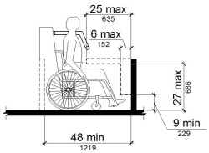
11B-1002.4.5 Ride Entry
Openings providing entry to wheelchair spaces on amusement rides shall be 32 inches (813 mm) minimum clear.
11B-1002.4.6 Approach
One side of the wheelchair space shall adjoin an accessible route when in the load and unload position.
11B-1002.4.7 Companion Seats
Where the interior width of the amusement ride is greater than 53 inches (1346 mm), seating is provided for more than one rider, and the wheelchair is not required to be centered within the amusement ride, a companion seat shall be provided for each wheelchair space.
11B-1002.4.7.1 Shoulder-to-Shoulder Seating
Where an amusement ride provides shoulder-to-shoulder seating, companion seats shall be shoulder-to-shoulder with the adjacent wheelchair space.
Exception: Where shoulder-to-shoulder companion seating is not operationally or structurally feasible, compliance with this requirement shall be required to the maximum extent practicable.
11B-1002.5 Amusement Ride Seats Designed for Transfer
Amusement ride seats designed for transfer shall comply with Section 11B-1002.5 when positioned for loading and unloading.
11B-1002.5.1 Clear Floor or Ground Space
A clear floor or ground space complying with Section 11B-305 shall be provided in the load and unload area adjacent to the amusement ride seats designed for transfer.
11B-1002.5.2 Transfer Height
The height of amusement ride seats designed for transfer shall be 14 inches (356 mm) minimum and 24 inches (610 mm) maximum measured from the surface of the load and unload area.
11B-1002.5.3 Transfer Entry
Where openings are provided for transfer to amusement ride seats, the openings shall provide clearance for transfer from a wheelchair or mobility aid to the amusement ride seat.
11B-1002.5.4 Wheelchair Storage Space
Wheelchair storage spaces complying with Section 11B-305 shall be provided in or adjacent to unload areas for each required amusement ride seat designed for transfer and shall not overlap any required means of egress or accessible route.
11B-1002.6 Transfer Devices for Use With Amusement Rides
Transfer devices for use with amusement rides shall comply with Section 11B-1002.6 when positioned for loading and unloading.
11B-1002.6.1 Clear Floor or Ground Space
A clear floor or ground space complying with Section 11B-305 shall be provided in the load and unload area adjacent to the transfer device.
11B-1002.6.2 Transfer Height
The height of transfer device seats shall be 14 inches (356 mm) minimum and 24 inches (610 mm) maximum measured from the load and unload surface.
11B-1002.6.3 Wheelchair Storage Space
Wheelchair storage spaces complying with Section 11B-305 shall be provided in or adjacent to unload areas for each required transfer device and shall not overlap any required means of egress or accessible route.
Section 11B-1003 Recreational Boating Facilities
11B-1003.1 General
Recreational boating facilities shall comply with Section 11B-1003.
11B-1003.2 Accessible Routes
Accessible routes serving recreational boating facilities, including gangways and floating piers, shall comply with Division 4 except as modified by the exceptions in Section 11B-1003.2.
11B-1003.2.1 Boat Slips
Accessible routes serving boat slips shall be permitted to use the exceptions in Section 11B-1003.2.1.
Exceptions:
- Where an existing gangway or series of gangways is replaced or altered, an increase in the length of the gangway shall not be required to comply with Section 11B-1003.2 unless required by Section 11B-202.4.
- Gangways shall not be required to comply with the maximum rise specified in Section 11B-405.6.
- Where the total length of a gangway or series of gangways serving as part of a required accessible route is 80 feet (24384 mm) minimum, gangways shall not be required to comply with Section 11B-405.2.
- Where facilities contain fewer than 25 boat slips and the total length of the gangway or series of gangways serving as part of a required accessible route is 30 feet (9144 mm) minimum, gangways shall not be required to comply with Section 11B-405.2.
- Where gangways connect to transition plates, landings specified by Section 11B-405.7 shall not be required.
- Where gangways and transition plates connect and are required to have handrails, handrail extensions shall not be required. Where handrail extensions are provided on gangways or transition plates, the handrail extensions shall not be required to be parallel with the ground or floor surface.
- The cross slope specified in Sections 11B-403.3 and 11B-405.3 for gangways, transition plates and floating piers that are part of accessible routes shall be measured in the static position.
- Changes in level complying with Sections 11B-303.3 and 11B-303.4 shall be permitted on the surfaces of gangways and boat launch ramps.
11B-1003.2.2 Boarding Piers at Boat Launch Ramps
Accessible routes serving boarding piers at boat launch ramps shall be permitted to use the exceptions in Section 11B-1003.2.2.
Exceptions:
- Accessible routes serving floating boarding piers shall be permitted to use Exceptions 1, 2, 5, 6, 7 and 8 in Section 11B-1003.2.1.
- Where the total length of the gangway or series of gangways serving as part of a required accessible route is 30 feet (9144 mm) minimum, gangways shall not be required to comply with Section 11B-405.2.
- Where the accessible route serving a floating boarding pier or skid pier is located within a boat launch ramp, the portion of the accessible route located within the boat launch ramp shall not be required to comply with Section 11B-405.
11B-1003.3 Clearances
Clearances at boat slips and on boarding piers at boat launch ramps shall comply with Section 11B-1003.3.
11B-1003.3.1 Boat Slip Clearance
Boat slips shall provide clear pier space 60 inches (1524 mm) wide minimum and at least as long as the boat slips. Each 10 feet (3048 mm) maximum of linear pier edge serving boat slips shall contain at least one continuous clear opening 60 inches (1524 mm) wide minimum.
Exceptions:
- Clear pier space shall be permitted to be 36 inches (914 mm) wide minimum for a length of 24 inches (610 mm) maximum, provided that multiple 36 inch (914 mm) wide segments are separated by segments that are 60 inches (1524 mm) wide minimum and 60 inches (1524 mm) long minimum.
- Edge protection shall be permitted at the continuous clear openings, provided that it is 4 inches (102 mm) high maximum and 2 inches (51 mm) wide maximum.
- In existing piers, clear pier space shall be permitted to be located perpendicular to the boat slip and shall extend the width of the boat slip, where the facility has at least one boat slip complying with Section 11B-1003.3, and further compliance with Section 11B-1003.3 would result in a reduction in the number of boat slips available or result in a reduction of the widths of existing slips.
FIGURE 11B-1003.3.1—
BOAT SLIP CLEARANCE
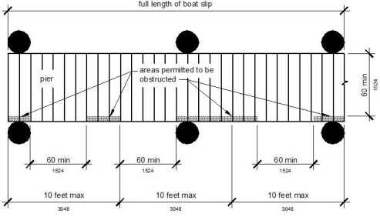
FIGURE 11B-1003.3.1 (EXCEPTION 1)—
CLEAR PIER SPACE REDUCTION AT BOAT SLIPS
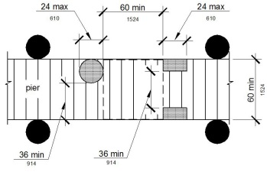
FIGURE 11B-1003.3.1 (EXCEPTION 2)—
EDGE PROTECTION AT BOAT SLIPS
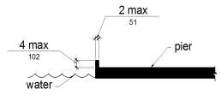
11B-1003.3.2 Boarding Pier Clearances
Boarding piers at boat launch ramps shall provide clear pier space 60 inches (1524 mm) wide minimum and shall extend the full length of the boarding pier. Every 10 feet (3048 mm) maximum of linear pier edge shall contain at least one continuous clear opening 60 inches (1524 mm) wide minimum.
Exceptions:
- The clear pier space shall be permitted to be 36 inches (914 mm) wide minimum for a length of 24 inches (610 mm) maximum provided that multiple 36 inch (914 mm) wide segments are separated by segments that are 60 inches (1524 mm) wide minimum and 60 inches (1524 mm) long minimum.
- Edge protection shall be permitted at the continuous clear openings provided that it is 4 inches (102 mm) high maximum and 2 inches (51 mm) wide maximum.
FIGURE 11B-1003.3.2—
BOARDING PIER CLEARANCE
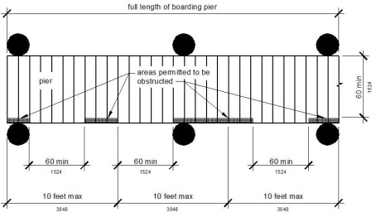
FIGURE 11B-1003.3.2 (EXCEPTION 1)—
CLEAR PIER SPACE REDUCTION AT BOARDING PIERS
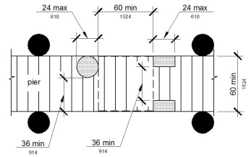
FIGURE 11B-1003.3.2 (EXCEPTION 2)—
EDGE PROTECTION AT BOARDING PIERS
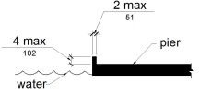
Section 11B-1004 Exercise Machines and Equipment
11B-1004.1 Clear Floor Space
Exercise machines and equipment shall have a clear floor space complying with Section 11B-305 positioned for transfer or for use by an individual seated in a wheelchair. Clear floor or ground spaces required at exercise machines and equipment shall be permitted to overlap.
Section 11B-1005 Fishing Piers and Platforms
11B-1005.1 Accessible Routes
Accessible routes serving fishing piers and platforms, including gangways and floating piers, shall comply with Division 4.
Exceptions:
- Accessible routes serving floating fishing piers and platforms shall be permitted to use Exceptions 1, 2, 5, 6, 7 and 8 in Section 11B-1003.2.1.
- Where the total length of the gangway or series of gangways serving as part of a required accessible route is 30 feet (9144 mm) minimum, gangways shall not be required to comply with Section 11B-405.2.
11B-1005.2 Railings
Where provided, railings, guards or handrails shall comply with Section 11B-1005.2.
11B-1005.2.1 Height
At least 25 percent of the railings, guards or handrails shall be 34 inches (864 mm) maximum above the ground or deck surface.
Exception: Where a guard complying with Chapter 10, Sections 1015.2 through 1015.4 is provided, the guard shall not be required to comply with Section 11B-1005.2.1.
11B-1005.2.1.1 Dispersion
Railings, guards or handrails required to comply with Section 11B-1005.2.1 shall be dispersed throughout the fishing pier or platform.
11B-1005.3 Edge Protection
Where railings, guards or handrails complying with Section 11B-1005.2 are provided, edge protection complying with Section 11B-1005.3.1 or 11B-1005.3.2 shall be provided.
11B-1005.3.1 Curb or Barrier
Curbs or barriers shall extend 2 inches (51 mm) minimum above the surface of the fishing pier or platform.
11B-1005.3.2 Extended Ground or Deck Surface
The ground or deck surface shall extend 12 inches (305 mm) minimum beyond the inside face of the railing. Toe clearance shall be provided and shall be 30 inches (762 mm) wide minimum and 9 inches (229 mm) minimum above the ground or deck surface beyond the railing.
FIGURE 11B-1005.3.2—
EXTENDED GROUND OR DECK SURFACE AT FISHING PIERS AND PLATFORMS
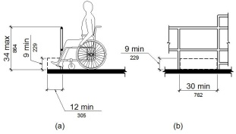
11B-1005.4 Clear Floor or Ground Space
At each location where there are railings, guards or handrails complying with Section 11B-1005.2.1, a clear floor or ground space complying with Section 11B-305 shall be provided. Where there are no railings, guards or handrails, at least one clear floor or ground space complying with Section 11B-305 shall be provided on the fishing pier or platform.
11B-1005.5 Turning Space
At least one turning space complying with Section 11B-304.3 shall be provided on fishing piers and platforms.
Section 11B-1006 Golf Facilities
11B-1006.1 General
Golf facilities shall comply with Section 11B-1006.
11B-1006.2 Accessible Routes
Accessible routes serving teeing grounds, practice teeing grounds, putting greens, practice putting greens, teeing stations at driving ranges, course weather shelters, golf car rental areas, bag drop areas and course toilet rooms shall comply with Division 4 and shall be 48 inches (1219 mm) wide minimum. Where handrails are provided, accessible routes shall be 60 inches (1524 mm) wide minimum.
Exception: Handrails shall not be required on golf courses. Where handrails are provided on golf courses, the handrails shall not be required to comply with Section 11B-505.
11B-1006.3 Golf Car Passages
Golf car passages shall comply with Section 11B-1006.3.
11B-1006.3.1 Clear Width
The clear width of golf car passages shall be 48 inches (1219 mm) minimum.
11B-1006.3.2 Barriers
Where curbs or other constructed barriers prevent golf cars from entering a fairway, openings 60 inches (1524 mm) wide minimum shall be provided at intervals not to exceed 75 yards (69 m).
11B-1006.4 Weather Shelters
A clear floor or ground space 60 inches (1524 mm) minimum by 96 inches (2438 mm) minimum shall be provided within weather shelters.
Section 11B-1007 Miniature Golf Facilities
11B-1007.1 General
Miniature golf facilities shall comply with Section 11B-1007.
11B-1007.2 Accessible Routes
Accessible routes serving holes on miniature golf courses shall comply with Division 4. Accessible routes located on playing surfaces of miniature golf holes shall be permitted to use the exceptions in Section 11B-1007.2.
Exceptions:
- Playing surfaces shall not be required to comply with Section 11B-302.2.
- Where accessible routes intersect playing surfaces of holes, a 1 inch (25 mm) maximum curb shall be permitted for a width of 32 inches (813 mm) minimum.
- A slope not steeper than 1:4 for a 4 inch (102 mm) maximum rise shall be permitted.
- Ramp landing slopes specified by Section 11B-405.7.1 shall be permitted to be 1:20 maximum.
- Ramp landing length specified by Section 11B-405.7.3 shall be permitted to be 48 inches (1219 mm) long minimum.
- Ramp landing size specified by Section 11B-405.7.4 shall be permitted to be 48 inches (1219 mm) minimum by 60 inches (1524 mm) minimum.
- Handrails shall not be required on holes. Where handrails are provided on holes, the handrails shall not be required to comply with Section 11B-505.
11B-1007.3 Miniature Golf Holes
Miniature golf holes shall comply with Section 11B-1007.3.
11B-1007.3.1 Start of Play
A clear floor or ground space 48 inches (1219 mm) minimum by 60 inches (1524 mm) minimum with slopes not steeper than 1:48 shall be provided at the start of play.
11B-1007.3.2 Golf Club Reach Range Area
All areas within holes where golf balls rest shall be within 36 inches (914 mm) maximum of a clear floor or ground space 36 inches (914 mm) wide minimum and 48 inches (1219 mm) long minimum having a running slope not steeper than 1:20. The clear floor or ground space shall be served by an accessible route.
FIGURE 11B-1007.3.2—
GOLF CLUB REACH RANGE AREA
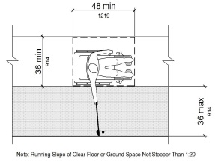
Section 11B-1008 Play Areas
11B-1008.1 General
Play areas shall comply with Section 11B-1008.
11B-1008.2 Accessible Routes
Accessible routes serving play areas shall comply with Division 4 and Section 11B-1008.2 and shall be permitted to use the exceptions in Sections 11B-1008.2.1 through 11B-1008.2.3. Where accessible routes serve ground level play components, the vertical clearance shall be 80 inches high (2032 mm) minimum.
11B-1008.2.1 Ground Level and Elevated Play Components
Accessible routes serving ground level play components and elevated play components shall be permitted to use the exceptions in Section 11B-1008.2.1.
Exceptions:
- Transfer systems complying with Section 11B-1008.3 shall be permitted to connect elevated play components except where 20 or more elevated play components are provided no more than 25 percent of the elevated play components shall be permitted to be connected by transfer systems.
- Where transfer systems are provided, an elevated play component shall be permitted to connect to another elevated play component as part of an accessible route.
11B-1008.2.2 Soft Contained Play Structures
Accessible routes serving soft contained play structures shall be permitted to use the exception in Section 11B-1008.2.2.
Exception: Transfer systems complying with Section 11B-1008.3 shall be permitted to be used as part of an accessible route.
11B-1008.2.3 Water Play Components
Accessible routes serving water play components shall be permitted to use the exceptions in Section 11B-1008.2.3.
Exceptions:
- Where the surface of the accessible route, clear floor or ground spaces or turning spaces serving water play components is submerged, compliance with Sections 11B-302, 11B-403.3, 11B-405.2, 11B-405.3 and 11B-1008.2.6 shall not be required.
- Transfer systems complying with Section 11B-1008.3 shall be permitted to connect elevated play components in water.
11B-1008.2.4 Clear Width
Accessible routes connecting play components shall provide a clear width complying with Section 11B-1008.2.4.
11B-1008.2.4.1 Ground Level
At ground level, the clear width of accessible routes shall be 60 inches (1524 mm) minimum.
Exceptions:
- In play areas less than 1000 square feet (93 m²), the clear width of accessible routes shall be permitted to be 44 inches (1118 mm) minimum, if at least one turning space complying with Section 11B-304.3 is provided where the restricted accessible route exceeds 30 feet (9144 mm) in length.
- The clear width of accessible routes shall be permitted to be 36 inches (914 mm) minimum for a distance of 60 inches (1524 mm) maximum provided that multiple reduced width segments are separated by segments that are 60 inches (1524 mm) wide minimum and 60 inches (1524 mm) long minimum.
11B-1008.2.4.2 Elevated
The clear width of accessible routes connecting elevated play components shall be 36 inches (914 mm) minimum.
Exceptions:
- The clear width of accessible routes connecting elevated play components shall be permitted to be reduced to 32 inches (813 mm) minimum for a distance of 24 inches (610 mm) maximum provided that reduced width segments are separated by segments that are 48 inches (1219 mm) long minimum and 36 inches (914 mm) wide minimum.
- The clear width of transfer systems connecting elevated play components shall be permitted to be 24 inches (610 mm) minimum.
11B-1008.2.5 Ramps
Within play areas, ramps connecting ground level play components and ramps connecting elevated play components shall comply with Section 11B-1008.2.5.
11B-1008.2.5.1 Ground Level
Ramp runs connecting ground level play components shall have a running slope not steeper than 1:16.
11B-1008.2.5.2 Elevated
The rise for any ramp run connecting elevated play components shall be 12 inches (305 mm) maximum.
11B-1008.2.5.3 Handrails
Diagram
Where required on ramps serving play components, the handrails shall comply with Section 11B-505 except as modified by Section 11B-1008.2.5.3.
Exceptions:
- Handrails shall not be required on ramps located within ground level use zones.
- Handrail extensions shall not be required.
UpCodes Diagram (1)
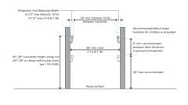
Ramp Handrail Height and Clearance (CA)
11B-1008.2.5.3.1 Handrail Gripping Surfaces
Handrail gripping surfaces with a circular cross section shall have an outside diameter of 0.95 inch (24 mm) minimum and 1.55 inches (39 mm) maximum. Where the shape of the gripping surface is non-circular, the handrail shall provide an equivalent gripping surface.
11B-1008.2.5.3.2 Handrail Height
The top of handrail gripping surfaces shall be 20 inches (508 mm) minimum and 28 inches (711 mm) maximum above the ramp surface.
11B-1008.2.6 Ground Surfaces
Ground surfaces on accessible routes, clear floor or ground spaces, and turning spaces shall comply with Section 11B-1008.2.6.
11B-1008.2.6.1 Accessibility
Ground surfaces shall comply with ASTM F1951. Ground surfaces shall be inspected and maintained regularly and frequently to ensure continued compliance with ASTM F1951.
11B-1008.2.6.2 Use Zones
Ground surfaces located within use zones shall comply with ASTM F1292 (1999 edition or 2004 edition).
11B-1008.3 Transfer Systems
Where transfer systems are provided to connect to elevated play components, transfer systems shall comply with Section 11B-1008.3.
11B-1008.3.1 Transfer Platforms
Transfer platforms shall be provided where transfer is intended from wheelchairs or other mobility aids. Transfer platforms shall comply with Section 11B-1008.3.1.
FIGURE 11B-1008.3.1—
TRANSFER PLATFORMS
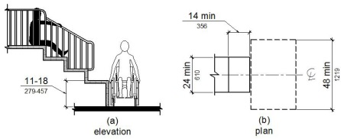
11B-1008.3.1.1 Size
Transfer platforms shall have level surfaces 14 inches (356 mm) deep minimum and 24 inches (610 mm) wide minimum.
11B-1008.3.1.2 Height
The height of transfer platforms shall be 11 inches (279 mm) minimum and 18 inches (457 mm) maximum measured to the top of the surface from the ground or floor surface.
11B-1008.3.1.3 Transfer Space
A transfer space complying with Sections 11B-305.2 and 11B-305.3 shall be provided adjacent to the transfer platform. The 48 inch (1219 mm) long minimum dimension of the transfer space shall be centered on and parallel to the 24 inch (610 mm) long minimum side of the transfer platform. The side of the transfer platform serving the transfer space shall be unobstructed.
11B-1008.3.1.4 Transfer Supports
At least one means of support for transferring shall be provided.
11B-1008.3.2 Transfer Steps
Transfer steps shall be provided where movement is intended from transfer platforms to levels with elevated play components required to be on accessible routes. Transfer steps shall comply with Section 11B-1008.3.2.
FIGURE 11B-1008.3.2—
TRANSFER STEPS
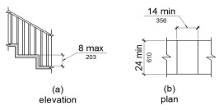
11B-1008.3.2.1 Size
Transfer steps shall have level surfaces 14 inches (356 mm) deep minimum and 24 inches (610 mm) wide minimum.
11B-1008.3.2.2 Height
Each transfer step shall be 8 inches (203 mm) high maximum.
11B-1008.3.2.3 Transfer Supports
At least one means of support for transferring shall be provided.
11B-1008.3.2.4 Contrasting Stripe
Diagram
Striping complying with Section 11B-504.4.1 shall be provided at each transfer step.
UpCodes Diagram (1)
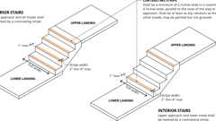
Stair Treads: Contrasting Stripe
11B-1008.4 Play Components
Ground level play components on accessible routes and elevated play components connected by ramps shall comply with Section 11B-1008.4.
11B-1008.4.1 Turning Space
At least one turning space complying with Section 11B-304 shall be provided on the same level as play components. Where swings are provided, the turning space shall be located immediately adjacent to the swing.
11B-1008.4.2 Clear Floor or Ground Space
Clear floor or ground space complying with Sections 11B-305.2 and 11B-305.3 shall be provided at play components.
11B-1008.4.3 Play Tables
Where play tables are provided, knee clearance 24 inches (610 mm) high minimum, 17 inches deep (432 mm) minimum, and 30 inches (762 mm) wide minimum shall be provided. The tops of rims, curbs or other obstructions shall be 31 inches (787 mm) high maximum.
Exception: Play tables designed and constructed primarily for children 5 years and younger shall not be required to provide knee clearance where the clear floor or ground space required by Section 11B-1008.4.2 is arranged for a parallel approach.
11B-1008.4.4 Entry Points and Seats
Where play components require transfer to entry points or seats, the entry points or seats shall be 11 inches (279 mm) minimum and 24 inches (610 mm) maximum from the clear floor or ground space.
Exception: Entry points of slides shall not be required to comply with Section 11B-1008.4.4.
11B-1008.4.5 Transfer Supports
Where play components require transfer to entry points or seats, at least one means of support for transferring shall be provided.
Section 11B-1009 Swimming Pools, Wading Pools and Spas
11B-1009.1 General
Where provided, pool lifts, sloped entries, transfer walls, transfer systems and pool stairs shall comply with Section 11B-1009.
11B-1009.2 Pool Lifts
Pool lifts shall comply with Section 11B-1009.2.
11B-1009.2.1 Pool Lift Location
Pool lifts shall be located where the water level is 36 inches (914 mm) minimum and 48 inches (1219 mm) maximum.
Exceptions:
- Where the entire pool depth is less than 36 inches (914 mm) or greater than 48 inches (1219 mm), compliance with Section 11B-1009.2.1 shall not be required.
- Where multiple pool lift locations are provided, no more than one pool lift shall be required to be located in an area where the water level is 48 inches (1219 mm) maximum.
11B-1009.2.2 Seat Location
In the raised position, the centerline of the seat shall be located over the deck and 16 inches (406 mm) minimum from the edge of the pool. The deck surface between the centerline of the seat and the pool edge shall have a slope not steeper than 1:48.
FIGURE 11B-1009.2.2—
POOL LIFT SEAT LOCATION
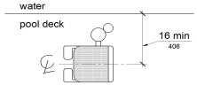
11B-1009.2.3 Clear Deck Space
On the side of the seat opposite the water, a clear deck space shall be provided parallel with the seat. The space shall be 36 inches (914 mm) wide minimum and shall extend forward 48 inches (1219 mm) minimum from a line located 12 inches (305 mm) behind the rear edge of the seat. The clear deck space shall have a slope not steeper than 1:48.
FIGURE 11B-1009.2.3—
CLEAR DECK SPACE AT POOL LIFTS
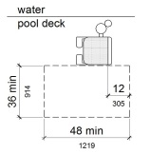
11B-1009.2.4 Seat
The seat shall be rigid and shall have a back support that is at least 12 inches (305 mm) tall. The height of the lift seat shall be designed to allow a stop at 17 inches (432 mm) minimum to 19 inches (483 mm) maximum measured from the deck to the top of the seat surface when in the raised (load) position. The seat shall have a restraint for the use of the occupant with operable parts complying with Section 11B-309.
FIGURE 11B-1009.2.4—
POOL LIFT SEAT HEIGHT
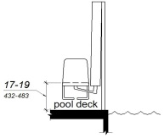
11B-1009.2.5 Seat Width
The seat shall be 16 inches (406 mm) wide minimum.
11B-1009.2.6 Footrests and Armrests
Footrests shall be provided and shall move with the seat. The seat shall have two armrests. The armrest positioned opposite the water shall be removable or shall fold clear of the seat when the seat is in the raised (load) position.
Exception: Footrests shall not be required on pool lifts provided in spas.
11B-1009.2.7 Operation
The lift shall be capable of unassisted operation from both the deck and water levels. Controls and operating mechanisms shall be unobstructed when the lift is in use and shall comply with Section 11B-309.4. The lift shall be stable and not permit unintended movement when a person is getting into or out of the seat.
11B-1009.2.8 Submerged Depth
The lift shall be designed so that the seat will submerge to a water depth of 18 inches (457 mm) minimum below the stationary water level.
FIGURE 11B-1009.2.8—
POOL LIFT SUBMERGED DEPTH
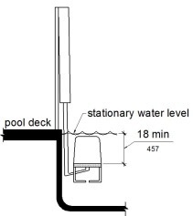
11B-1009.2.9 Lifting Capacity
Single person pool lifts shall have a weight capacity of 300 pounds (136 kg) minimum and be capable of sustaining a static load of at least one and a half times the rated load.
11B-1009.3 Sloped Entries
Sloped entries shall comply with Section 11B-1009.3.
11B-1009.3.1 Sloped Entries
Sloped entries shall comply with Division 4 except as modified in Sections 11B-1009.3.1 through 11B-1009.3.3.
Exception: Where sloped entries are provided, the surfaces shall not be required to be slip resistant.
11B-1009.3.2 Submerged Depth
Sloped entries shall extend to a depth of 24 inches (610 mm) minimum and 30 inches (762 mm) maximum below the stationary water level. Where landings are required by Section 11B-405.7, at least one landing shall be located 24 inches (610 mm) minimum and 30 inches (762 mm) maximum below the stationary water level.
Exception: In wading pools, the sloped entry and landings, if provided, shall extend to the deepest part of the wading pool.
FIGURE 11B-1009.3.2—
SLOPED ENTRY SUBMERGED DEPTH
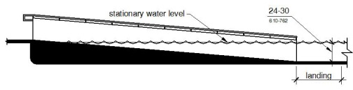
11B-1009.3.3 Handrails
At least two handrails complying with Section 11B-505 shall be provided on the sloped entry. The clear width between required handrails shall be 33 inches (838 mm) minimum and 38 inches (965 mm) maximum.
Exceptions:
- Handrail extensions specified by Section 11B-505.10.1 shall not be required at the bottom landing serving a sloped entry.
- Where a sloped entry is provided for wave action pools, leisure rivers, sand bottom pools and other pools where user access is limited to one area, the handrails shall not be required to comply with the clear width requirements of Section 11B-1009.3.3.
- Sloped entries in wading pools shall not be required to provide handrails complying with Section 11B-1009.3.3. If provided, handrails on sloped entries in wading pools shall not be required to comply with Section 11B-505.
FIGURE 11B-1009.3.3—
HANDRAILS FOR SLOPED ENTRY
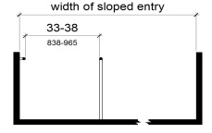
11B-1009.4 Transfer Walls
Transfer walls shall comply with Section 11B-1009.4.
11B-1009.4.1 Clear Deck Space
A clear deck space of 60 inches (1524 mm) minimum by 60 inches (1524 mm) minimum with a slope not steeper than 1:48 shall be provided at the base of the transfer wall. Where one grab bar is provided, the clear deck space shall be centered on the grab bar. Where two grab bars are provided, the clear deck space shall be centered on the clearance between the grab bars.
FIGURE 11B-1009.4.1—
CLEAR DECK SPACE AT TRANSFER WALLS
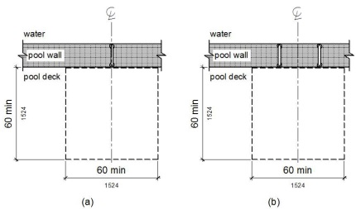
11B-1009.4.2 Height
The height of the transfer wall shall be 16 inches (406 mm) minimum and 19 inches (483 mm) maximum measured from the deck.
FIGURE 11B-1009.4.2—
TRANSFER WALL HEIGHT
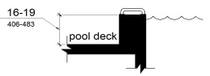
11B-1009.4.3 Wall Depth and Length
The depth of the transfer wall shall be 12 inches (305 mm) minimum and 16 inches (406 mm) maximum. The length of the transfer wall shall be 60 inches (1524 mm) minimum and shall be centered on the clear deck space.
FIGURE 11B-1009.4.3—
DEPTH AND LENGTH OF TRANSFER WALLS
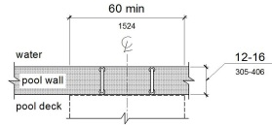
11B-1009.4.4 Surface
Surfaces of transfer walls shall not be sharp and shall have rounded edges.
11B-1009.4.5 Grab Bars
At least one grab bar complying with Section 11B-609 shall be provided on the transfer wall. Grab bars shall be perpendicular to the pool wall and shall extend the full depth of the transfer wall. The top of the gripping surface shall be 4 inches (102 mm) minimum and 6 inches (152 mm) maximum above transfer walls. Where one grab bar is provided, clearance shall be 24 inches (610 mm) minimum on both sides of the grab bar. Where two grab bars are provided, clearance between grab bars shall be 24 inches (610 mm) minimum.
Exception: Grab bars on transfer walls shall not be required to comply with Section 11B-609.4.
FIGURE 11B-1009.4.5—
GRAB BARS FOR TRANSFER WALLS
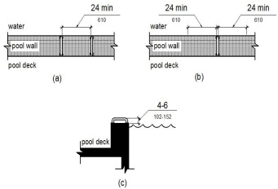
11B-1009.5 Transfer Systems
Transfer systems shall comply with Section 11B-1009.5.
11B-1009.5.1 Transfer Platform
A transfer platform shall be provided at the head of each transfer system. Transfer platforms shall provide 19 inches (483 mm) minimum clear depth and 24 inches (610 mm) minimum clear width.
FIGURE 11B-1009.5.1—
SIZE OF TRANSFER PLATFORM
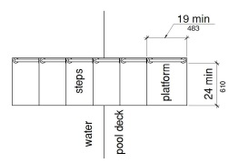
11B-1009.5.2 Transfer Space
A transfer space of 60 inches (1524 mm) minimum by 60 inches (1524 mm) minimum with a slope not steeper than 1:48 shall be provided at the base of the transfer platform surface and shall be centered along a 24 inch (610 mm) minimum side of the transfer platform. The side of the transfer platform serving the transfer space shall be unobstructed.
FIGURE 11B-1009.5.2—
CLEAR DECK SPACE AT TRANSFER PLATFORM
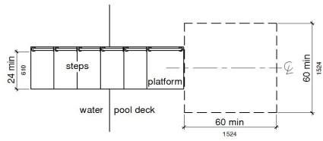
11B-1009.5.3 Height
The height of the transfer platform shall comply with Section 11B-1009.4.2.
11B-1009.5.4 Transfer Steps
Transfer step height shall be 8 inches (203 mm) maximum. The surface of the bottom tread shall extend to a water depth of 18 inches (457 mm) minimum below the stationary water level.
FIGURE 11B-1009.5.4—
TRANSFER STEPS
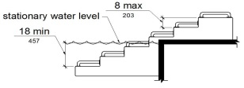
11B-1009.5.5 Surface
The surface of the transfer system shall not be sharp and shall have rounded edges.
11B-1009.5.6 Size
Each transfer step shall have a tread clear depth of 14 inches (356 mm) minimum and 17 inches (432 mm) maximum and shall have a tread clear width of 24 inches (610 mm) minimum.
FIGURE 11B-1009.5.6—
SIZE OF TRANSFER STEPS
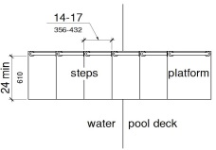
11B-1009.5.7 Grab Bars
At least one grab bar on each transfer step and the transfer platform or a continuous grab bar serving each transfer step and the transfer platform shall be provided. Where a grab bar is provided on each step, the tops of gripping surfaces shall be 4 inches (102 mm) minimum and 6 inches (152 mm) maximum above each step and transfer platform. Where a continuous grab bar is provided, the top of the gripping surface shall be 4 inches (102 mm) minimum and 6 inches (152 mm) maximum above the step nosing and transfer platform. Grab bars shall comply with Section 11B-609 and be located on at least one side of the transfer system. The grab bar located at the transfer platform shall not obstruct transfer.
Exception: Grab bars on transfer systems shall not be required to comply with Section 11B-609.4.
FIGURE 11B-1009.5.7—
GRAB BARS
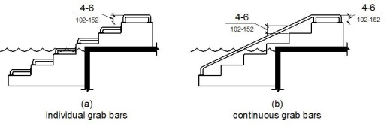
11B-1009.6 Pool Stairs
Pool stairs shall comply with Section 11B-1009.6.
11B-1009.6.1 Pool Stairs
Pool stairs shall comply with Section 11B-504.
Exception: Pool step riser heights shall not be required to be 4 inches (102 mm) high minimum and 7 inches (178 mm) high maximum provided that riser heights are uniform.
11B-1009.6.2 Handrails
The width between handrails shall be 20 inches (508 mm) minimum and 24 inches (610 mm) maximum. Handrail extensions required by Section 11B-505.10.3 shall not be required on pool stairs.
Section 11B-1010 Shooting Facilities With Firing Positions
11B-1010.1 Turning Space
A circular turning space 60 inches (1524 mm) diameter minimum with slopes not steeper than 1:48 shall be provided at shooting facilities with firing positions.

